*A project report on*

**Health Hub-CENTRALIZED HEALTHCARE MANAGEMENT SYSTEM**

*Submitted in partial fulfillment for the award of the degree*

Bachelor of Technology

in

**Computer Science Engineering**

*by*

**VIGNESH CP (19BCE0432)**



## SCHOOL OF COMPUTER SCIENCE AND ENGINEERING

May, 2023

**DECLARATION**

I here by declare that the thesis entitled “Health Hub-CENTRALIZED HEALTHCARE MANAGEMENT SYSTEM” submitted by me, for the award of the degree of Bachelor of Technology in Computer Science and Engineering, VIT is a record of bonafide work carried out by me under the VK Srividya.

I further declare that the work reported in this thesis has not been submitted and will not be submitted, either in part or in full, for the award of any other degree or diploma in this institute or any other institute or university.

Place: Bengaluru

Date:28/05/2023 Signature of the Candidate

Internship completion certificate

**ABSTRACT**

Living with a chronic illness often entails a frustrating and disjointed healthcare experience, with patients struggling to convey their complete medical history to multiple doctors and specialists. This fragmented approach hampers effective decision-making and impedes personalized care. However, the emergence of a centralized healthcare system offers a promising solution. This abstract explores the transformative impact of such a system on patients' lives.

By consolidating medical records into a single repository, the centralized healthcare system ensures that all pertinent information is easily accessible to healthcare providers. This streamlines the consultation process, eliminating the need for patients to repeatedly recount their medical history. Doctors can now review comprehensive records, gaining valuable insights into the patient's condition, treatment history, and diagnostic tests without unnecessary delays.

The newfound ability of healthcare providers to access a holistic view of a patient's health leads to more informed decision-making. Armed with complete medical records, doctors can develop personalized care plans tailored to each patient's unique needs. The system facilitates collaboration among healthcare professionals, promoting better coordination of care and reducing the risk of miscommunication or oversight.

**ACKNOWLEDGEMENT**

It is my pleasure to express with deep sense of gratitude to VK Srividya Senior Developer,

Enquero Global for her constant guidance, continual encouragement, understanding; more than all, she taught me patience in my endeavor. My association with her is not confined to academics only, but it is a great opportunity on my part of work with an intellectual and expert in the field of Application development.

I would like to express my gratitude to G Viswanathan, GV Selvam, Rambabu Kodali, Dr Ramesh Babu K, School of Computer Science and Engineering, for providing with an environment to work in and for his inspiration during the tenure of the course.

In jubilant mood I express ingeniously my whole-hearted thanks to Karthick Uppara, Senior Manager, all teaching staff and members working as limbs of our university for their not-self-centered enthusiasm coupled with timely encouragements showered on me with zeal, which prompted the acquirement of the requisite knowledge to finalize my course study successfully. I would like to thank my parents for their support.

It is indeed a pleasure to thank my friends who persuaded and encouraged me to take up and complete this task. At last but not least, I express my gratitude and appreciation to all those who have helped me directly or indirectly toward the successful completion of this project.

Place: Bengaluru

Date:28/05/23 Vignesh CP

## CONTENTS

CONTENTS iv

LIST OF FIGURES ix

LIST OF TABLES xi

LIST OF ACRONYMS xii

CHAPTER 1 INTRODUCTION

* 1. INTRODUCTION 1
  2. OVERVIEW OF MANET NETWORK 2
  3. CHALLENGES PRESENT IN MANET 6
  4. PROJECT STATEMENT 7
  5. OBJECTIVES 7
  6. SCOPE OF THE PROJECT 8

CHAPTER 2 BACK GROUND

* 1. INTRODUCTION 10
  2. SURVEY ON MANETS 13

### LIST OF FIGURES

* 1. INFRA STRUCTURE BASED NETWORK 1
  2. INFRA STRUCTURE LESS NETWORK 2
  3. MOBILE AD-HOC NETWORK 4

*iv*

**LIST OF TABLES**

2.1 MULTIPATH ROUTING PROTOCOLS IN AMNETS 22

* 1. SIMULATION PARAMETERS 48

*v*

**LIST OF ACRONYMS**

MANET Mobile Ad hoc Network WAP Wireless Access Point

**Chapter 1**

**Introduction**

* 1. Introduction

In the realm of healthcare, the management of medical records plays a crucial role in facilitating effective diagnosis, treatment, and overall patient care. However, the current landscape is characterized by fragmented information systems and disjointed communication among healthcare providers. This situation often leads to delays, redundant tests, and inadequate understanding of patients' complete medical history. In an effort to address these challenges, a centralized medical records system has emerged, promising to revolutionize healthcare delivery. This article explores the transformative potential of such a system, focusing on its ability to provide healthcare providers with comprehensive patient information, improve clinical decision-making, enhance patient outcomes, and ensure equitable access for patients from diverse backgrounds and age groups.

Comprehensive Patient Information:

One of the primary advantages of a centralized medical records system is the ability to collate and maintain comprehensive patient information. Traditional paper-based or fragmented electronic records are prone to errors, omissions, and limited accessibility. With a centralized system, patients' medical records, including diagnoses, treatments, medications, test results, and allergies, are stored in a single secure location. This consolidation enables healthcare providers to obtain a holistic view of a patient's medical history, ensuring better-informed clinical decision-making.

Enhanced Clinical Decision-Making:

The availability of complete and up-to-date medical records empowers healthcare providers to make more accurate and informed clinical decisions. By having access to a patient's entire medical history, doctors can identify patterns, evaluate treatment responses, and predict potential complications. This comprehensive understanding enables the development of personalized treatment plans tailored to the individual needs of each patient. Centralized systems can also integrate decision support tools, such as clinical guidelines and evidence-based recommendations, further augmenting the quality of care.

Improved Patient Outcomes:

A centralized medical records system has the potential to significantly impact patient outcomes. With seamless access to comprehensive patient information, healthcare providers can avoid redundant tests, unnecessary treatments, and medication errors. The system can also flag potential drug interactions or allergies, reducing adverse events and improving patient safety. Moreover, the ability to track and monitor patients' progress over time allows for timely interventions, early detection of complications, and better management of chronic conditions. Overall, these benefits contribute to improved patient outcomes and enhanced quality of life.

Care Coordination and Collaboration:

In a decentralized medical records environment, care coordination among healthcare providers can be challenging, leading to miscommunication, duplicated efforts, and fragmented care. A centralized system addresses these issues by promoting seamless information sharing and collaboration. With access to a patient's complete medical history, multiple providers involved in a patient's care can make well-informed decisions, ensuring continuity and coherence in treatment plans. Enhanced communication and coordination among specialists, primary care physicians, and other healthcare professionals result in a more holistic and integrated approach to patient care.

Equitable Access and Patient Empowerment:

A centralized medical records system has the potential to bridge gaps in healthcare access and empower patients from diverse backgrounds and age groups. By aggregating and standardizing medical records, the system can ensure equitable access to healthcare services, regardless of geographical location or socioeconomic status. Patients can benefit from improved care coordination, reduced wait times, and minimized administrative burden. Furthermore, patients gain greater control and involvement in their healthcare decisions as they have access to their own medical records. This empowerment fosters better patient-provider communication and facilitates shared decision-making.

Privacy and Data Security:

The implementation of a centralized medical records system necessitates stringent privacy and data security measures to protect patient information. Robust encryption protocols, access controls, and authentication mechanisms should be in place to ensure confidentiality. Compliance with data protection regulations, such as the Health Insurance Portability and Accountability Act (HIPAA), is crucial to maintain patient trust. Additionally, implementing audits, monitoring systems, and comprehensive training

* 1. PROJECT OVERVIEW

The primary overview of this project is to develop a healthcare website that enables patients and healthcare providers to upload, access, and manage medical records efficiently. By centralizing patient information, the website aims to empower patients to take control of their health, reduce the burden of managing medical records, and enable healthcare providers to make informed decisions. The website's user-friendly interface and accessibility cater to patients of all ages and backgrounds, ensuring equitable access to healthcare services.

Patient-Centric Care:

A key feature of the patient-centric healthcare system is its focus on individual patients' needs and preferences. The website enables patients to access their health information, view and update their medical records, track health indicators, and receive personalized health recommendations. By actively involving patients in their care decisions, the system promotes patient empowerment, engagement, and shared decision-making between patients and healthcare providers.

Seamless Care Coordination:

The patient centralized healthcare system facilitates seamless care coordination and continuity across various healthcare settings. It streamlines transitions between hospitals, clinics, and home care, ensuring that healthcare providers have access to complete and up-to-date medical records. This interoperability enhances care coordination, reduces redundant tests and treatments, and promotes better communication among healthcare providers, resulting in improved patient outcomes.

System Design and Features:

The website's design focuses on usability, security, and interoperability. Patients can securely upload their medical records, including diagnoses, treatments, medications, and test results. The system employs robust encryption protocols and access controls to ensure the confidentiality and privacy of patient information. User-friendly interfaces and intuitive navigation enhance the patient experience, facilitating efficient record management.

Benefits for Patients:

Patients benefit from the centralized healthcare system in several ways. They have easy access to their medical records, eliminating the need to repeatedly provide their medical history to different healthcare providers. Patients can actively participate in their care decisions, review their health information, and monitor their progress. The system provides personalized health recommendations and reminders for appointments, medications, and preventive screenings, promoting proactive and preventive care.

Benefits for Healthcare Providers:

The centralized healthcare system significantly improves healthcare providers' efficiency and decision-making capabilities. With comprehensive patient information readily available, healthcare providers can quickly assess the patient's medical history, previous treatments, and test results. This knowledge enables more accurate diagnoses, appropriate treatment plans, and timely interventions. Collaboration among healthcare providers is facilitated through shared access to patient records, enabling seamless care coordination and reducing the risk of errors or duplications.

Measuring Success and Impact:

The success and impact of the centralized healthcare system can be evaluated through various indicators. Patient satisfaction surveys can measure the system's ability to meet patient needs, enhance access to care, and improve the patient-provider relationship. Health outcomes, such as reduced hospital readmissions, improved adherence to treatment plans, and better management of chronic conditions, demonstrate the system's effectiveness in improving patient care. Additionally, cost-effectiveness analyses can assess the system's impact on healthcare resource utilization and overall healthcare expenditures.

Challenges and Considerations:

Implementing a patient-centered centralized healthcare system requires addressing several challenges. Ensuring data security and privacy is paramount, as sensitive patient information is stored and transmitted. Compliance with regulatory requirements, such as HIPAA, must be strictly adher.

Patient Registration and Profile Management:

Patients can create an account and complete their profile, providing essential demographic information, medical history, and preferences. This information helps healthcare providers deliver personalized care and tailor recommendations to the patient's specific needs.

Secure Medical Record Upload:

Patients can securely upload their medical records, including laboratory test results, imaging reports, medication history, and vaccination records. The system employs encryption and data integrity measures to safeguard sensitive patient information.

Comprehensive Medical History:

The website maintains a centralized repository of patient medical records, allowing healthcare providers to access a complete overview of the patient's health history. This includes diagnoses, treatments, surgical procedures, allergies, and chronic conditions, enabling informed decision-making and personalized care planning.

Appointment Scheduling and Reminders:

Patients can conveniently schedule appointments with healthcare providers through the website. Automated reminders via email or SMS help patients stay organized and ensure they do not miss important appointments or follow-up visits.

Personalized Health Recommendations:

Based on the patient's medical history and health indicators, the system provides personalized health recommendations, preventive screenings, and lifestyle interventions. This promotes proactive healthcare and empowers patients to adopt healthy habits.

Secure Messaging and Telehealth:

The website facilitates secure messaging between patients and healthcare providers, allowing for quick communication, clarification of doubts, and follow-up queries. Telehealth features enable remote consultations, reducing the need for in-person visits, especially for follow-up appointments or minor health concerns.

* 1. Challenges

Data Security and Privacy:

Protecting patient data is of utmost importance. Ensuring secure transmission, storage, and access control measures to safeguard sensitive medical records is a significant challenge. Compliance with relevant regulations, such as HIPAA (Health Insurance Portability and Accountability Act), is essential to maintain patient confidentiality.

Interoperability:

Integrating the website with existing healthcare systems and electronic health record (EHR) platforms may present challenges. The website needs to effectively communicate and exchange data with various healthcare providers, labs, and diagnostic centers to provide a comprehensive view of the patient's medical history.

System Integration:

Integrating the website with different healthcare facilities, such as hospitals, clinics, and home care services, may require overcoming technical barriers. Ensuring smooth interoperability between the website and existing healthcare systems can be complex, as different systems may use different data formats and protocols.

User Adoption and Training:

Encouraging patients and healthcare providers to adopt and effectively utilize the website can be a challenge. Ensuring user-friendly interfaces, intuitive navigation, and providing comprehensive training and support resources are essential to promote user adoption and optimize the system's benefits.

Standardization of Data Formats:

The healthcare industry lacks standardized data formats and terminologies, making it challenging to integrate and interpret data from different sources. Implementing standardized data formats, such as HL7 (Health Level Seven) or FHIR (Fast Healthcare Interoperability Resources), can help overcome these challenges and ensure seamless data exchange.

Scalability and Performance:

As the number of users and data volume increases, the website should be capable of handling scalability and ensuring optimal performance. Designing a robust and scalable architecture, optimizing database performance, and implementing caching mechanisms are critical to support a growing user base.

Technical Support and Maintenance:

Continuous technical support and maintenance are necessary to address issues, perform updates, and ensure the smooth functioning of the website. Promptly addressing any technical glitches, software updates, and user feedback is crucial to maintaining user satisfaction and system reliability.

Regulatory Compliance:

Compliance with healthcare regulations, such as HIPAA, GDPR (General Data Protection Regulation), and local data protection laws, is essential. The website should adhere to these regulations to protect patient privacy and avoid legal consequences.

Resistance to Change:

Healthcare systems often face resistance to change from both patients and healthcare providers. Overcoming resistance, addressing concerns, and effectively communicating the benefits and value of the centralized healthcare system are important factors in successful adoption.

Ethical Considerations: Ethical considerations, such as informed consent, data ownership, and patient autonomy, should be carefully addressed. Clear communication about data usage, privacy policies, and patient rights is necessary to maintain trust and ensure ethical practices.

* 1. Problem Statement

Imagine you are a patient with a chronic illness. You've been seeing multiple doctors and specialists for years, but you feel like no one has a complete picture of your health. Every time you see a new doctor, you must go through your medical history again, and you're not sure if they have access to all the information, they need to make the best decisions for your care.On top of that, you struggle to remember all the details of your health history, like when you had certain tests done or what medications you've tried in the past. You feel like you're constantly starting over and it's frustrating.One day, you hear about a new healthcare system that promises to solve these problems.

It's centralized, which means all your medical records will be in one place, and your doctors will have access to the same information. Plus, it is designed to prioritize your needs as a patient, with personalized care plans and easy access to your records.You decide to try it and sign up for the new system. Suddenly, everything changes. Your doctors can see your complete medical history with just a few clicks and make more informed decisions about your care.

You no longer must go through your medical history every time you see a new doctor, and you feel more confident that you are getting the best care possible.With the centralized healthcare system, you feel like you are finally in control of your health and can focus on living your life instead of worrying about managing your medical records.

* 1. Objective
* The primary objective of this healthcare project is to enhance the quality of patient care. By centralizing patient data, healthcare providers can have a comprehensive view of patients' medical history, diagnoses, medications, and test results. This enables more accurate diagnoses, effective treatment planning, and improved care coordination among different providers. Ultimately, the objective is to enhance patient outcomes, satisfaction, and overall health.
* Additionally, the healthcare website will streamline and optimize operational processes within the healthcare organization. A centralized system can automate administrative tasks, reduce paperwork, and improve the efficiency of data management. This can lead to time and cost savings, improved resource utilization, and a more productive workflow for healthcare providers.
* In traditional healthcare systems, patient information is often fragmented and scattered across different providers and healthcare facilities. This fragmentation can hinder effective care coordination, leading to fragmented and inefficient care delivery. A centralized healthcare system enables healthcare providers to access and share comprehensive patient information, facilitating seamless care coordination and continuity across different settings and providers.
* Moreover, this system promotes continuity of care, particularly in cases where patients receive care from multiple providers or undergo transitions between different healthcare settings. By consolidating patient information in a central repository, healthcare providers can access comprehensive and consistent data, enabling them to provide personalized and informed care across different points of care.
* In conclusion, a patient centralized healthcare system aims to enhance care coordination, patient safety, efficiency, patient empowerment, data analytics, and compliance, ultimately improving the overall quality of healthcare delivery and patient outcomes.
  1. SCOPE OF THE PROJECT

The project scope of a patient centralized healthcare system encompasses various elements and objectives aimed at implementing an effective and comprehensive system. Firstly, it involves the consolidation and integration of patient data from various sources, such as electronic health records, medical devices, and other healthcare systems.

This includes ensuring interoperability and seamless data exchange between different providers and healthcare settings. Additionally, the project scope encompasses the implementation of features and functionalities that facilitate care coordination and collaboration among healthcare providers.

Finally, the project scope includes ongoing maintenance, updates, and enhancements of the centralized healthcare system to keep pace with technological advancements, regulatory requirements, and evolving healthcare needs.

In summary, the project scope of a patient centralized healthcare system covers data integration, user-friendly interfaces, secure data management, care coordination features, decision support tools, patient engagement functionalities, training and change management activities, and system maintenance. By defining a clear project scope, healthcare organizations can effectively plan, develop, and implement a patient centralized healthcare system that meets the needs of patients, healthcare providers, and the organization.

**CHAPTER-2**

**BACKGROUND**

2.1 Background

The development of a centralized healthcare system aims to address various challenges and limitations in traditional healthcare models. By consolidating patient information, improving care coordination, enhancing patient safety, empowering individuals, leveraging data-driven insights, and ensuring compliance and data security, such a system has the potential to revolutionize healthcare delivery. This article provides an in-depth analysis of the needs and benefits of a patient-centric centralized healthcare system and its implications for improving patient outcomes and experiences.

1. Fragmentation of Patient Information and Care Coordination Challenges:

One of the primary needs for a centralized healthcare system is to overcome the fragmented nature of patient information across multiple providers and facilities. In traditional systems, patient data is often siloed, leading to inefficiencies, redundancies, and gaps in care. By centralizing patient information, healthcare providers can access comprehensive and up-to-date data, facilitating informed decision-making and seamless care coordination. This promotes continuity of care, reduces medical errors, and enhances overall patient safety.

1. Empowering and Engaging Patients in their Healthcare:

A central aspect of a patient-centered healthcare system is empowering individuals to actively participate in their own healthcare journey. By granting patients access to their health records, test results, and treatment plans, they can become informed partners in their care. Patient empowerment fosters shared decision-making, promotes patient education, and increases adherence to treatment plans. Ultimately, this leads to improved health outcomes, increased patient satisfaction, and a sense of ownership over one's health.

1. Leveraging Data-Driven Insights for Improved Care:

A centralized healthcare system enables the aggregation and analysis of patient data, providing valuable insights for healthcare organizations. By leveraging data analytics and population health management strategies, healthcare providers can identify trends, patterns, and areas for improvement in healthcare delivery. Data-driven insights help in the development of targeted interventions, preventive care strategies, and personalized treatment plans. This approach optimizes resource allocation, reduces healthcare costs, and enhances the overall quality of care provided to patients.

1. Enhancing Patient Safety and Quality of Care:

In traditional healthcare systems, fragmented patient information can lead to medical errors, adverse events, and compromised patient safety. A centralized healthcare system mitigates these risks by ensuring that healthcare providers have access to accurate, up-to-date patient information at the point of care. This facilitates timely and informed decision-making, reduces duplication of tests and procedures, and enhances medication management. The result is an improved patient safety culture, reduced healthcare-associated infections, and enhanced overall quality of care.

1. Compliance and Data Security:

In an era of increasing concerns about data privacy and security, a centralized healthcare system must adhere to stringent regulatory requirements. Compliance with regulations such as the Health Insurance Portability and Accountability Act (HIPAA) ensures the protection of patient data and maintains patient trust. Implementing robust data security measures, including encryption, access controls, and audit trails, is vital to safeguard sensitive medical information and prevent unauthorized access or breaches.

CHAPTER-3

PROJECT DESCRIPTION AND GOALS

3.1 Tech Stack

3.1.1 FRONTEND:

HTML

HTML (Hypertext Markup Language) is the standard markup language used for creating the structure and presenting the content on web pages. It provides a set of tags and elements that define the layout, headings, paragraphs, images, links, and other elements of a webpage. HTML forms the backbone of any web page and is essential for creating the structure and content hierarchy.

HTML is a markup language that uses a system of tags to structure the content of a web page. Tags are enclosed in angle brackets and usually come in pairs, with an opening tag and a closing tag. The opening tag denotes the beginning of an element, while the closing tag denotes the end. Elements can also be self-closing, where the opening tag includes a forward slash before the closing angle bracket.

HTML provides a wide range of elements to structure and format the content of a web page. For example, the **<h1>** to **<h6>** tags are used to define different levels of headings, with **<h1>** being the highest level and **<h6>** being the lowest. The **<p>** tag is used to define paragraphs, and the **<img>** tag is used to insert images into the page. Links are created using the **<a>** tag, and lists can be created using the **<ul>**, **<ol>**, and **<li>** tags for unordered and ordered lists.

CSS

CSS (Cascading Style Sheets) is a style sheet language used to describe the presentation and visual styling of HTML elements. It allows you to control the layout, colors, fonts, spacing, and other visual aspects of a web page. CSS works by associating style rules with HTML elements, enabling you to create visually appealing and consistent designs across multiple web pages.

With CSS, you can define styles for various HTML elements using selectors. Selectors target specific HTML elements or groups of elements, and the associated styles define how those elements should be displayed. CSS provides a wide range of properties that allow you to control the appearance of elements, such as **color** for text color, **font-family** for the font type, **margin** for spacing, and **background-color** for the background color.

One of the key advantages of CSS is its ability to separate the presentation from the content. By defining styles in a separate CSS file or within the **<style>** tags in the HTML document, you can apply consistent styles to multiple pages, making it easier to maintain and update the visual appearance of your website. CSS also offers the concept of cascading, where conflicting styles are resolved based on specificity, inheritance, and order of declaration.

JAVASCRIPT

JavaScript is a high-level programming language that adds interactivity and dynamic behavior to web pages. It enables you to create interactive features, handle events, manipulate the content of a page, and communicate with servers to fetch or send data. JavaScript is widely used for client-side scripting, making web pages more interactive and responsive.

JavaScript allows you to add functionality to your web pages by attaching event handlers to HTML elements. Event handlers can respond to user actions such as clicks, mouse movements, and keystrokes. By writing JavaScript code within these event handlers, you can manipulate the HTML elements, modify their content, or perform calculations.

JavaScript also provides a wide range of built-in functions and objects that allow you to perform complex operations and interact with the browser environment. For example, you can use the **document** object to access and modify the content of a web page, the **window** object to manipulate the browser window, and the **XMLHttpRequest** object to make HTTP requests to servers.

In addition to client-side scripting, JavaScript can also be used on the server-side with the help of server-side JavaScript frameworks such as Node.js.

REACT

React is a JavaScript library for building user interfaces. It was developed by Facebook and is widely used in the industry for creating interactive and dynamic web applications. React follows a component-based architecture, where the UI is broken down into reusable and self-contained components. This modular approach makes it easier to manage the complexity of large-scale applications and encourages code reusability.

One of the key features of React is its use of a virtual DOM. The virtual DOM is a lightweight representation of the actual DOM (the HTML document structure) that React uses for efficient rendering and updating of components. When there is a change in the application's state, React compares the virtual DOM with the actual DOM and updates only the necessary components, resulting in better performance and a smoother user experience.

React promotes a declarative programming style, where developers describe what the UI should look like based on the current state, rather than imperatively manipulating the DOM. This makes it easier to understand and maintain the code, as developers can focus on the desired outcome rather than the specific steps to achieve it.

React also provides powerful tools for managing component state and handling user interactions. With the use of hooks, developers can add stateful logic to functional components, allowing them to manage local component state and perform side effects. React also supports a unidirectional data flow, where data is passed from parent components to child components through props, making it easier to track and debug data changes.

BOOTSTRAP

Bootstrap, on the other hand, is a popular front-end framework that provides a set of pre-built CSS and JavaScript components. It offers a responsive grid system, typography styles, form elements, navigation components, modals, and much more. Bootstrap follows a mobile-first approach, ensuring that websites built with it are responsive and adapt well to different screen sizes and devices.

One of the advantages of using Bootstrap is that it provides a consistent and visually appealing design out of the box. Developers can leverage the ready-made components and styles to quickly build a professional-looking website without spending much time on designing from scratch. The components are designed to be customizable, allowing developers to tailor them to their specific needs and branding.

Bootstrap also offers a responsive grid system that simplifies the creation of responsive layouts. The grid system divides the page into 12 columns and allows developers to easily arrange and align content in a flexible and responsive manner. This ensures that the website looks good on different devices and screen sizes, providing a seamless user experience.

In addition to the CSS components, Bootstrap includes JavaScript plugins that enhance the functionality and interactivity of the website. These plugins provide features like dropdown menus, carousels, tooltips, modals, and more. The integration of these plugins is straightforward, requiring minimal effort from the developers.

Overall, React and Bootstrap complement each other well in web development. React provides a powerful framework for building dynamic and interactive user interfaces, while Bootstrap offers a comprehensive set of CSS and JavaScript components for fast and responsive website development. Combining these two technologies can result in efficient and visually appealing web applications.

3.1.2 BACKEND:

MONGODB

MongoDB is a popular NoSQL (non-relational) database that has gained significant popularity in recent years. It differs from traditional relational databases by using a flexible, document-oriented data model instead of tables with fixed schemas. In MongoDB, data is stored as JSON-like documents, allowing for easy representation of complex structures and relationships.

One of the key advantages of MongoDB is its scalability. It is designed to handle large amounts of data and high traffic loads, making it suitable for applications with rapidly growing data requirements. MongoDB can be easily scaled horizontally by distributing data across multiple servers, which enables seamless expansion as the application's needs evolve.

Another important feature of MongoDB is its high performance. It uses an in-memory storage engine and supports indexing, which allows for fast and efficient data retrieval. Additionally, MongoDB employs a technique called sharding, which partitions data across multiple machines to distribute the workload and improve performance.

MongoDB also provides rich querying capabilities. It supports a flexible query language that allows developers to perform complex queries, including filtering, sorting, and aggregations. Queries can be executed against multiple fields within a document or across multiple documents, making it easy to retrieve the desired data.

MONGOOSE

Mongoose, on the other hand, is an Object Data Modeling (ODM) library for MongoDB and Node.js. It provides a higher-level abstraction over MongoDB, making it easier to work with data models and perform database operations. Mongoose allows developers to define schemas for their data, enforcing structure and validation rules.

One of the key features of Mongoose is its ability to define relationships between data models. It supports various types of relationships, such as one-to-one, one-to-many, and many-to-many, allowing developers to establish connections between different types of data. Mongoose provides convenient methods for querying and populating related data, simplifying the handling of complex data relationships.

Mongoose also offers features like middleware, which allows developers to define pre and post hooks for various operations, such as saving or deleting documents. This enables developers to add custom logic and perform additional actions before or after specific database operations.

In addition to data modeling and querying, Mongoose provides utilities for data validation, data manipulation, and schema migrations. It integrates well with the Node.js ecosystem and provides a seamless experience for developers working with MongoDB.

Overall, MongoDB and Mongoose form a powerful combination for building scalable and flexible applications that require efficient data storage and retrieval. MongoDB's document-oriented model and scalability features make it an excellent choice for handling large volumes of data, while Mongoose simplifies the process of working with MongoDB by providing an intuitive and convenient way to define data models and perform database operations.

EXPRESS

Express is a popular web application framework built on top of Node.js. It provides a minimalist and unopinionated approach to building web applications, allowing developers to have more control over the architecture and design choices. Express offers a set of robust features and utilities that simplify the process of handling HTTP requests, routing, middleware management, and view rendering.

One of the key advantages of Express is its simplicity. It provides a minimalistic and lightweight framework that focuses on the core functionality needed for web development. This simplicity allows developers to have more flexibility in designing and structuring their applications according to their specific needs.

Express follows the middleware pattern, which allows developers to chain multiple middleware functions to handle incoming requests. Middleware functions can perform various tasks, such as parsing request bodies, handling authentication, logging, error handling, and more. This modular approach makes it easy to extend the functionality of an Express application by adding or removing middleware as needed.

Routing in Express is intuitive and flexible. Developers can define routes for different HTTP methods (GET, POST, PUT, DELETE, etc.) and specify the corresponding handler functions. This allows for easy separation of concerns and organization of code based on different endpoints and actions.

Express also provides support for template engines, allowing developers to render dynamic views and generate HTML pages on the server side. Popular template engines such as EJS, Pug, and Handlebars can be easily integrated with Express to provide server-side rendering capabilities.

In addition to its core features, Express has a vast ecosystem of middleware modules and extensions that can be easily integrated into an application. These modules provide additional functionalities such as session management, authentication, authorization, caching, validation, and more. The modular nature of Express allows developers to choose and integrate only the specific modules they need, keeping the application lightweight and efficient.

Moving on to crypto-js, it is a JavaScript library that provides a comprehensive set of cryptographic functions and algorithms. It enables developers to perform various cryptographic operations such as encryption, decryption, hashing, and message authentication codes (MACs) in a browser or Node.js environment.

CRYPTO-JS

Crypto-js offers a wide range of cryptographic algorithms, including AES (Advanced Encryption Standard), HMAC (Hash-based Message Authentication Code), SHA (Secure Hash Algorithm), and more. These algorithms are essential for securing sensitive data, protecting user privacy, and ensuring the integrity of transmitted information.

One of the advantages of using crypto-js is its ease of use and consistent API. The library provides a simple and intuitive interface for performing cryptographic operations, making it accessible to developers with varying levels of expertise in cryptography.

Crypto-js supports both symmetric and asymmetric encryption, allowing developers to choose the most appropriate encryption method based on their requirements. It also provides options for generating secure random numbers, encoding and decoding data in various formats, and working with cryptographic keys.

In web applications, crypto-js is commonly used for encrypting passwords, generating secure tokens for authentication, encrypting data before storing it in databases, and securing data during transmission over networks. It helps developers implement strong security measures without having to delve deep into the complexities of cryptographic algorithms.

Overall, Express and crypto-js are powerful tools that simplify web application development and enhance security. Express provides a lightweight and flexible framework for building web applications, while crypto-js offers a comprehensive set of cryptographic functions for securing sensitive data. Combining these two technologies enables developers to create robust, secure, and scalable web applications.

JWT

JWT (JSON Web Token) is an open standard that provides a compact and self-contained way to securely transmit information between parties as a JSON object. It is widely used in web applications as a means of authentication and authorization. JWTs are often employed in stateless scenarios, where the server doesn't need to store session data or user information.

The structure of a JWT consists of three main parts: the header, the payload, and the signature. The header contains metadata about the token, such as the algorithm used for signing the token. The payload carries the claims, which are statements about the user or additional data. Common claims include the user's identity, permissions, and any additional information required for the application. The signature is created by combining the encoded header, payload, and a secret key, providing integrity and ensuring that the token has not been tampered with.

One of the key advantages of JWT is its self-contained nature. The token itself contains all the necessary information, eliminating the need for the server to maintain session state. This makes JWTs particularly useful in distributed systems and microservices architectures, where maintaining session state across multiple servers or services can be challenging.

JWTs are typically used for authentication purposes. When a user successfully logs in to an application, a JWT is issued and sent to the client. The client then includes the JWT in subsequent requests, typically in the Authorization header of the HTTP request. The server can verify the authenticity and integrity of the JWT by validating the signature using the secret key. Once validated, the server can extract the user's identity and other claims from the payload to authorize access to protected resources.

Another advantage of JWT is its flexibility. The payload of the token can be customized to include any relevant information about the user or application. This flexibility allows developers to include additional data, such as user roles, permissions, and expiration dates. However, it is important to note that sensitive information should not be included in the JWT payload, as the contents of the token can be decoded by anyone with access to it.

JWTs are also portable, which means they can be used across different platforms and technologies. Since the token itself is a self-contained JSON object, it can be easily transmitted over HTTP, stored in cookies, or included in the URL parameters. This makes JWTs compatible with a wide range of systems and frameworks.

When implementing JWT authentication, it is crucial to handle token expiration and revocation properly. JWTs can have an expiration time (defined in the payload), and once a token expires, it should no longer be considered valid. Additionally, if a user's permissions change or their account is compromised, the server should have mechanisms in place to invalidate or revoke the JWT.

In summary, JWT is a versatile and secure method for transmitting information between parties. Its self-contained nature, flexibility, and portability make it a popular choice for implementing authentication and authorization in web applications. By leveraging JWTs, developers can create stateless and scalable systems while ensuring the integrity and security of user data.

3.1.3 DEPLOYMENT:

RENDER

Render is a cloud platform that provides a modern approach to hosting and deploying web applications and static sites. It offers a simple and scalable infrastructure for developers to deploy their applications without the complexity of managing servers or infrastructure. Render supports a wide range of programming languages, frameworks, and databases, making it suitable for various types of web applications.

Key Features and Benefits of Render:

a. Easy Deployment: Render makes the deployment process seamless and straightforward. You can connect your code repository (e.g., GitHub, GitLab) to Render, and it will automatically build and deploy your application whenever changes are pushed to the repository. This eliminates the need for manual deployments and simplifies the release process.

b. Scalability and Performance: Render automatically scales your application based on demand, ensuring high availability and optimal performance. It provides automatic horizontal scaling, load balancing, and intelligent routing to distribute traffic across instances. This enables your application to handle increased traffic and ensures a smooth user experience.

c. Automatic HTTPS and SSL Certificates: Render provides built-in support for HTTPS and automatically provisions SSL certificates for your domains. This ensures that your application is secure and encrypted, establishing trust with your users and improving SEO rankings.

d. Collaborative Workflows: Render offers collaborative features that allow teams to work together efficiently. You can invite team members to manage deployments, set up custom access controls, and collaborate on application settings and configurations.

e. Infrastructure Automation: Render abstracts away the complexities of infrastructure management. It automatically handles tasks such as provisioning and scaling servers, managing databases, and handling DNS configurations. This frees up developers to focus on building their applications rather than managing infrastructure.

NETLIFY

Netlify is a popular web development platform that specializes in hosting static websites and deploying modern web projects. It provides an all-in-one solution for building, deploying, and managing static sites and serverless functions. Netlify aims to simplify the web development workflow and offers powerful features for developers and teams.

Key Features and Benefits of Netlify:

a. Continuous Deployment: Netlify integrates seamlessly with popular version control platforms like GitHub, GitLab, and Bitbucket. It automatically builds and deploys your static site whenever changes are pushed to the repository. This enables continuous integration and deployment (CI/CD), ensuring that your website is always up to date.

b. Static Site Generation: Netlify supports modern static site generators like Gatsby, Hugo, and Jekyll. It provides a build environment and build processes optimized for these generators, allowing you to create dynamic and performant static sites. Netlify also offers server-side rendering (SSR) capabilities for sites built with frameworks like Next.js.

c. Forms and Functions: Netlify provides form handling functionality, allowing you to easily capture and process form submissions without the need for a backend server. It also supports serverless functions, enabling you to execute server-side logic and integrate with APIs or databases.

d. Global CDN and Performance Optimization: Netlify leverages a global content delivery network (CDN) to ensure that your website is served quickly to users worldwide. It automatically optimizes assets, performs image optimizations, and applies caching strategies to improve site performance.

e. Custom Domains and SSL: Netlify allows you to easily configure custom domains for your websites and provides free SSL certificates using Let's Encrypt. This ensures that your site is accessible securely via HTTPS, providing a secure and trustworthy browsing experience.

f. Team Collaboration and Deployment Previews: Netlify provides collaboration features, allowing teams to work together efficiently. It offers role-based access controls, deployment previews for reviewing changes before they go live, and collaboration tools for managing projects and deployments.

CHAPTER-4

METHODOLOGY

4.1 Software Models

The Software Development Life Cycle (SDLC) is a framework that outlines the various stages involved in the development of software applications. It provides a systematic and structured approach to software development, ensuring that software products are created efficiently, with high quality and adherence to requirements. The SDLC consists of several phases, each with specific objectives, activities, and deliverables.

Here are the common phases of the SDLC:

1. Requirement Gathering and Analysis: In this initial phase, project stakeholders collaborate to gather and document software requirements. This involves understanding the needs of end-users, defining functional and non-functional requirements, and identifying project constraints. The goal is to establish a clear understanding of the desired software functionality.
2. System Design: In this phase, the system architecture and design are planned. The software's overall structure, modules, and interfaces are defined. It involves creating detailed technical specifications, selecting appropriate technologies, and ensuring that the system design aligns with the identified requirements.
3. Implementation: During the implementation phase, the actual coding of the software takes place. Developers write code according to the design specifications, following coding best practices and coding standards. This phase involves unit testing, code reviews, and ensuring the code is modular, maintainable, and well-documented.
4. Testing: The testing phase involves validating the software against the defined requirements. Various types of testing are conducted, such as functional testing, performance testing, security testing, and usability testing. The objective is to identify defects or issues and ensure that the software meets the quality standards.
5. Deployment: In the deployment phase, the software is released for end-users. This includes activities such as installing the software, configuring the system, and ensuring compatibility with the target environment. It may involve migration of data, setting up production servers, and providing necessary user documentation.
6. Maintenance: After deployment, the software enters the maintenance phase. This involves addressing user feedback, bug fixes, and updates to meet changing requirements. Maintenance may also include enhancements, optimization, and ongoing support to ensure the software remains functional and secure.

Types of SDLC:

1. Waterfall Model: The Waterfall model follows a linear sequential approach, with each phase being completed before moving to the next. It is a highly structured and document-driven model. While it offers clarity and simplicity, it lacks flexibility for accommodating changes during development.
2. Agile Model: Agile methodologies, such as Scrum and Kanban, emphasize iterative and incremental development. They promote adaptive planning, collaboration, and frequent customer involvement. Agile methods focus on delivering working software in short iterations, allowing for flexibility, continuous feedback, and the ability to respond to changing requirements.
3. Spiral Model: The Spiral model combines elements of the Waterfall model and iterative development. It involves multiple iterations, with each iteration passing through four main phases: planning, risk analysis, engineering, and evaluation. The Spiral model emphasizes risk management and is suitable for large, complex projects.
4. Iterative Model: The Iterative model breaks down the software development process into smaller iterations. Each iteration includes requirements gathering, design, coding, and testing. It allows for progressive refinement and improvement of the software based on feedback received during each iteration.
5. V-Model: The V-Model is a verification and validation model that emphasizes testing throughout the development life cycle. It establishes a relationship between each development phase and its corresponding testing phase. The V-Model ensures that testing activities are aligned with the requirements and design.
6. Rapid Application Development (RAD): RAD is a model that focuses on rapid prototyping, iterative development, and user feedback. It aims to accelerate development time by involving end-users in the design and development process. RAD is particularly suited for projects with well-defined requirements and where speed is a priority.

4.2 Reason for choosing Agile Model:

1. Flexibility and Adaptability: Agile allows for changes in requirements, priorities, and market conditions, enabling teams to respond quickly and deliver value faster.
2. Customer Collaboration: Agile fosters active customer involvement throughout the development process, ensuring that the product meets their needs and expectations.
3. Faster Time to Market: Agile's iterative approach and focus on delivering working software in short sprints enable faster delivery and quicker response to market demands.
4. Continuous Improvement: Agile promotes a culture of continuous learning and improvement through regular feedback and retrospectives, leading to enhanced team performance and higher-quality products.
5. Transparency and Communication: Agile methodologies emphasize frequent communication, collaboration, and transparency within the development team and with stakeholders, reducing misunderstandings and improving project visibility.
6. Increased Team Morale: Agile methodologies empower teams, promote self-organization, and encourage shared responsibility, leading to higher team morale and motivation.

4.3 Agile Model

Agile methodology is an iterative and incremental approach to software development that emphasizes flexibility, collaboration, and continuous improvement. It aims to deliver high-quality software products in a more efficient and adaptive manner compared to traditional waterfall approaches. The Agile methodology values individuals and interactions, working software, customer collaboration, and responding to change.

Key Principles of Agile Methodology:

1. Customer Satisfaction: Agile places a strong emphasis on understanding and satisfying customer needs through early and continuous delivery of valuable software. Regular feedback from customers is sought to ensure that the delivered software meets their expectations.
2. Iterative and Incremental Development: Agile projects are divided into short iterations or sprints, typically lasting 1-4 weeks. Each iteration involves cross-functional teams working collaboratively to deliver a potentially shippable increment of the product. This iterative approach allows for continuous improvement and adaptability.
3. Self-Organizing Teams: Agile encourages self-organizing and cross-functional teams that have the autonomy to make decisions and manage their own work. Team members collaborate closely, share knowledge, and collectively take ownership of project deliverables.
4. Embracing Change: Agile recognizes that requirements and priorities can change throughout a project. It embraces change by allowing for flexibility and adjusting plans accordingly. Changes are accommodated through regular feedback, iterative planning, and continuous collaboration with stakeholders.
5. Continuous Feedback and Improvement: Agile promotes regular feedback loops to validate assumptions, identify issues, and make improvements. Frequent demonstrations of working software to customers and stakeholders encourage transparency and prompt feedback. Retrospectives at the end of each iteration help teams reflect on their processes and identify areas for improvement.

Common Agile Methodologies:

1. Scrum: Scrum is one of the most widely used Agile methodologies. It follows a time-boxed approach with short iterations called sprints. The project is divided into a backlog of user stories, and the team collaboratively selects a set of stories to work on in each sprint. Daily stand-up meetings, sprint planning, sprint reviews, and retrospectives are core components of Scrum.
2. Kanban: Kanban focuses on visualizing work and limiting work in progress (WIP). It uses a Kanban board to represent different stages of work, such as "To Do," "In Progress," and "Done." Teams pull work items from the backlog as capacity allows, promoting a steady flow of work and enabling continuous delivery.
3. Lean Software Development: Lean methodology aims to minimize waste and maximize customer value. It emphasizes continuous improvement, value stream mapping, and eliminating non-value-adding activities. Lean focuses on delivering the highest value with the least effort and resources.

Challenges of Agile Methodology:

1. Changing Requirements: Frequent changes in requirements can sometimes pose challenges in terms of scope creep, impacting project timelines and budgets.
2. Time and Resource Management: The dynamic nature of Agile requires efficient planning and resource allocation

4.4 Sprint-Deliverables

Sprint 1:

• Creating the wireframe of the website using Miro

• Creating a work plan based on the wireframe created beforehand.

• Designing the login and sign in pages

• Creating database modelsfor backend of the website

Sprint 2:

• Patient Portal with integration of database

Patient portal is for patients to log in to view, update their medical records or add new

records. We will be integrating the database model to the frontend.

Sprint 3:

• Hospital portal with integration of database and complete demonstration

Hospital portal is for doctorsto log in to view or add new records of the patient who they

are examining.We will be integrating the database model to the frontend.

• Complete demonstration of the project

CHAPTER-4

DESIGN

4.1 WIREFRAME MODEL

A wireframe is a visual representation or blueprint of a website's structure and layout. It is a simplified and static representation of the website's user interface, devoid of colors, graphics, and detailed visuals. The purpose of a wireframe is to outline the basic elements and functionality of a web page, allowing designers, developers, and stakeholders to visualize and understand the website's structure before moving on to the actual design and development process.

Key Elements of a Website Wireframe:

1. Layout and Structure: The wireframe defines the overall layout and structure of the web page, including the placement of header, footer, navigation menus, sidebars, content sections, and other key components. It helps establish a clear hierarchy of information and the flow of user interaction.
2. Content Placement: The wireframe identifies the areas where various types of content will be placed, such as text, images, videos, and interactive elements. It helps designers and stakeholders determine the content's positioning, size, and prominence on the page.
3. Navigation and Interactivity: The wireframe outlines the navigation structure, including menus, submenus, dropdowns, and links. It provides a visual representation of how users will move through the website and access different sections or pages. It may also indicate interactive elements like buttons, forms, search bars, and other user interface components.
4. Functionality and Features: Wireframes can showcase the basic functionality and features of the website, such as buttons, form fields, checkboxes, radio buttons, and other interactive elements. It helps stakeholders understand how users will interact with the website and accomplish specific tasks.

Benefits of Creating Website Wireframes:

1. Visualizing Information Architecture: Wireframes help in planning and organizing the website's information architecture. They provide a clear and visual representation of the site's structure, allowing stakeholders to evaluate and refine the layout and content placement.
2. Early Conceptualization and Iteration: Wireframes facilitate early-stage conceptualization and iteration. Designers and stakeholders can quickly experiment with different layout options, content arrangements, and interaction patterns without investing too much time and effort. This allows for rapid iteration and refinement of ideas.
3. Collaboration and Communication: Wireframes serve as a communication tool between designers, developers, and stakeholders. They provide a common visual language that helps all parties involved understand and discuss the website's layout, functionality, and user experience. It allows for effective collaboration and feedback gathering.
4. User Experience Planning: Wireframes allow designers to focus on user experience (UX) planning by considering the placement of content, navigation flow, and interactive elements. They help identify potential usability issues early on, enabling designers to make informed decisions and improvements to enhance the overall user experience.
5. Cost and Time Efficiency: By visualizing the website's structure and functionality in wireframes, potential issues and design flaws can be identified and resolved early in the process. This reduces the need for major revisions during the later stages of design and development, saving both time and cost.

Tools for Creating Website Wireframes:

There are numerous tools available for creating website wireframes, ranging from simple sketching tools to dedicated wireframing software. Some popular wireframing tools include:

1. Sketch
2. Adobe XD
3. Balsamiq
4. Figma
5. Axure RP
6. InVision
7. Moqups
8. Miro

These tools offer various features like drag-and-drop interface elements, pre-built templates, collaboration capabilities, and the ability to simulate interactions, making the wireframing process more efficient and effective.

In summary, website wireframes play a crucial role in the web design process. They provide a visual blueprint of the website's structure, layout, and functionality, allowing designers, developers, and stakeholders to collaborate, iterate, and make informed decisions before moving on to the actual.

4.2 Advantages of using Miro

Miro is a collaborative online whiteboard platform that offers a wide range of features and benefits for teams working on various projects. Here are some advantages of using Miro:

1. Collaborative Environment: Miro provides a collaborative space where team members can work together in real-time, regardless of their geographical locations. Multiple team members can simultaneously contribute, edit, and comment on the board, fostering collaboration and enhancing productivity.
2. Flexible and Versatile: Miro offers a variety of templates, shapes, and widgets that can be used to create different types of content, including diagrams, wireframes, mind maps, user flows, and more. It allows teams to adapt the tool to their specific needs and work on a wide range of projects.
3. Remote Team Collaboration: With the rise of remote work, Miro becomes particularly valuable. It enables remote teams to work together seamlessly, eliminating the need for physical whiteboards or in-person meetings. Remote team members can contribute and collaborate in real-time, promoting effective communication and coordination.
4. Visual Organization: Miro provides a visual and spatial layout for organizing and presenting information. Teams can use it to create structured diagrams, flowcharts, and boards, making it easier to understand complex concepts and relationships. The visual nature of Miro enhances clarity and helps team members align their understanding.
5. Integration Capabilities: Miro integrates with various third-party tools and platforms, such as Jira, Slack, Google Drive, and Microsoft Office. This allows teams to connect their existing workflows and seamlessly incorporate Miro into their overall toolchain, improving efficiency and streamlining work processes.
6. Remote Workshops and Brainstorming: Miro offers a range of features specifically designed for remote workshops and brainstorming sessions. Teams can utilize digital sticky notes, voting systems, timers, and facilitation tools to conduct collaborative brainstorming sessions remotely, enabling creativity and ideation regardless of physical location.
7. Documentation and Version Control: Miro provides features for capturing and documenting discussions, ideas, and decisions made during collaborative sessions. It allows teams to save and review the board history, making it easy to track changes, revert to previous versions, and maintain an audit trail of the project's progress.
8. Accessibility and Availability: Miro is a cloud-based platform accessible through web browsers and mobile apps, making it available across multiple devices and operating systems. Team members can access their boards and collaborate on the go, ensuring flexibility and availability whenever needed.
9. Presentation and Sharing Capabilities: Miro allows teams to present their boards in real-time, either through video conferencing or screen sharing. It enables smooth and interactive presentations, allowing stakeholders to provide feedback and participate actively in discussions.
10. Extensive Support and Community: Miro offers comprehensive support resources, including tutorials, guides, and customer support channels. Additionally, Miro has a large and active community, allowing users to share tips, best practices, and learn from others' experiences.

Overall, Miro provides a powerful and versatile platform for collaborative visual work, enhancing team collaboration, remote work capabilities, and creativity in various domains.

4.3 Wireframe applied for the website:

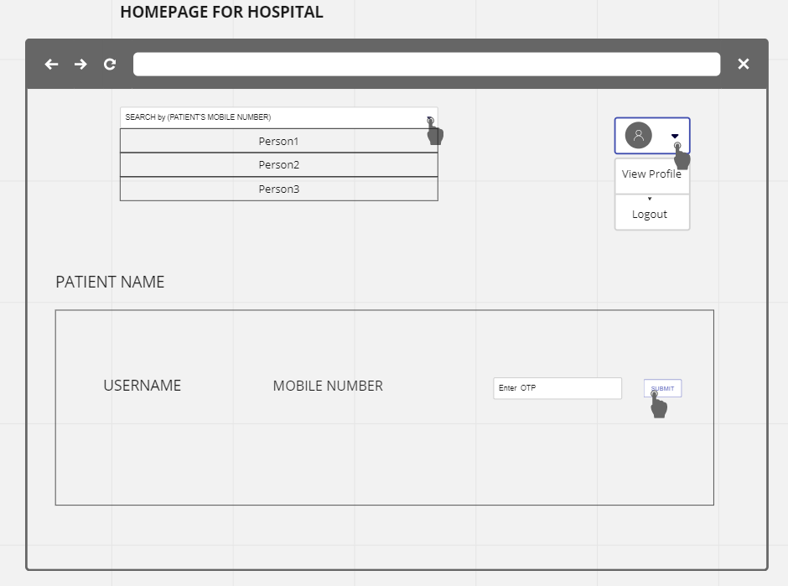

*Fig-1* *Homepage of hospital*

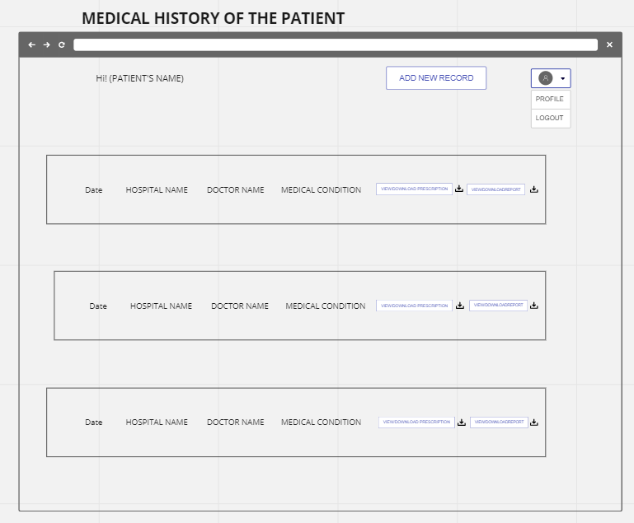

*Fig-2 Medical history of patient*

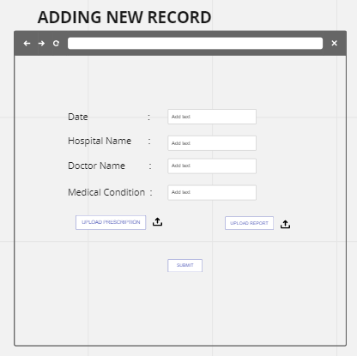

*Fig-3 Adding new record*

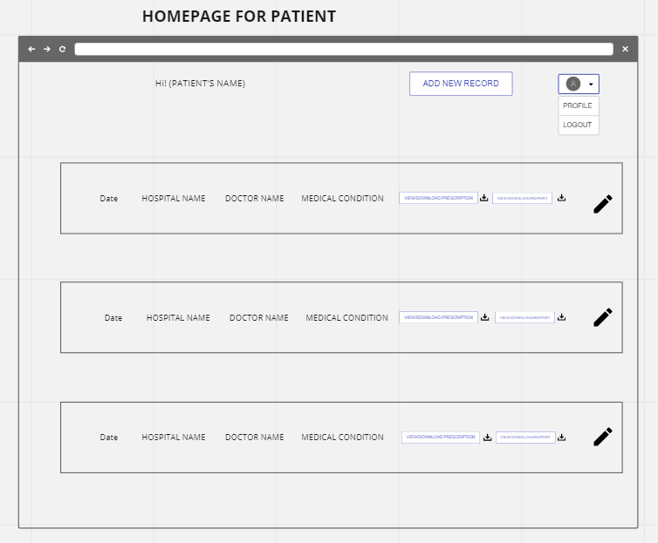

*Fig-4 Homepage for patient*

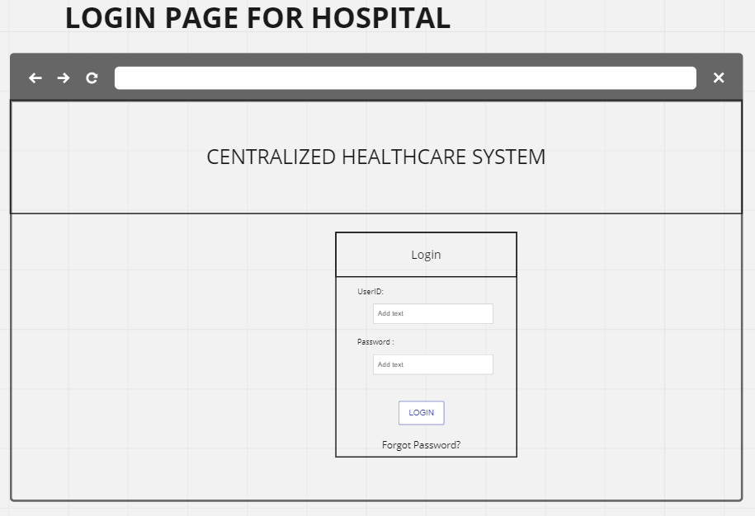

*Fig-5 Login for hospital*

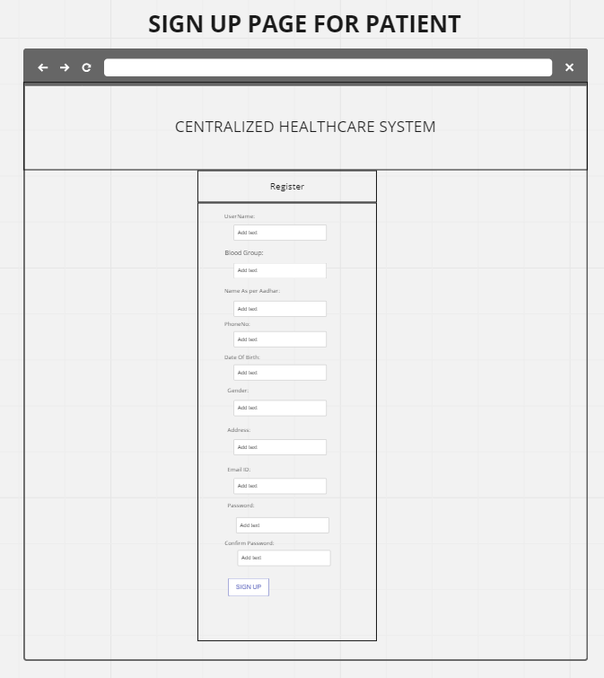

*Fig-6 SignUp for patients*

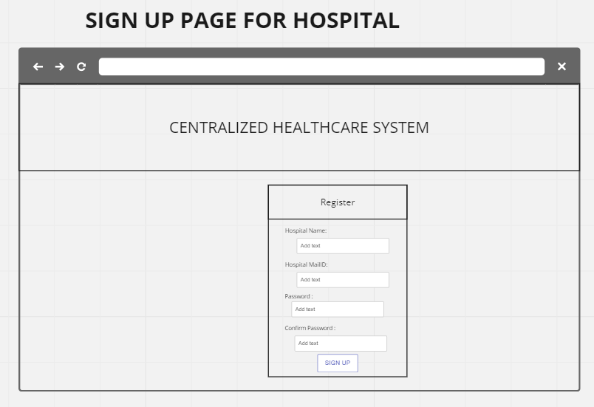

*Fig-7 SignUp for hospitals*

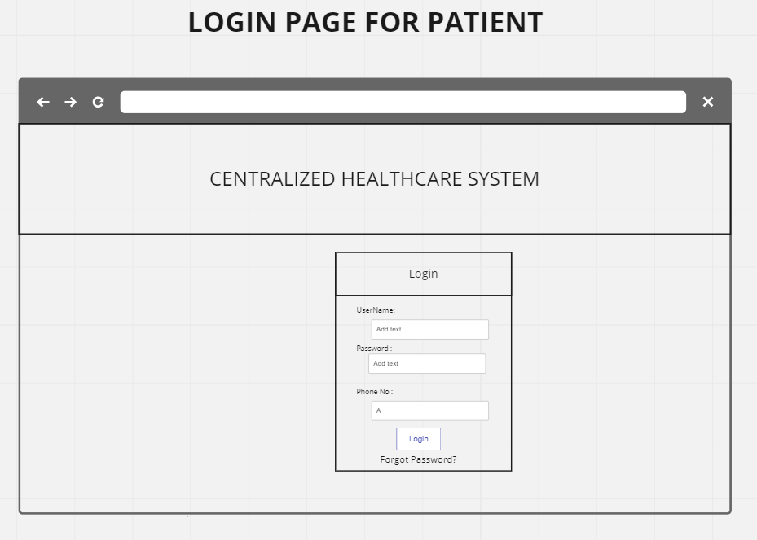

*Fig-8 Login for patients*

4.4 Timeline

1.Planning Phase (1-2 weeks):

• Define project scope and requirements.

• Identify project stakeholders and establish communication channels.

• Develop project plan, timeline, and budget.

• Establish project team roles and responsibilities.

2. Design Phase (3-4 weeks):

• Develop a patient portal that allows patients to view, update, and add medical records

from their homes.

• Integrate the database model with the frontend of the website.

3. Development Phase (5-6 weeks):

• Develop a hospital portal that allows healthcare providers to view and add new medical

records for patients.

• Integrate the database model with the frontend of the website.

• Demonstrate the completed website after the integration of the front-end and database.

CHAPTER-5

TECHNICAL ANALYSIS

5.1 Functional Requirements:

5.1.1 Product perspective

The patient-centered healthcare system operates within the broader context of the existing healthcare infrastructure and electronic medical record (EMR) systems. It is designed to seamlessly integrate with these systems to ensure the continuity of patient information and avoid duplicating efforts. By integrating with existing infrastructure, the system can leverage the available data and provide a unified view of the patient's health information.

Integration with EMR systems is crucial for consolidating patient records and enabling healthcare providers to access and update patient information efficiently. The patient-centered system will establish secure connections and protocols to retrieve and store data from EMR systems, ensuring that the latest and most accurate information is available to healthcare providers and patients. This integration eliminates the need for duplicate data entry and minimizes the risk of information discrepancies.

Additionally, the patient-centered healthcare system will have a user-friendly interface that complements the existing EMR systems. It will provide a seamless experience for both patients and healthcare providers, allowing them to access and interact with the system without significant disruptions to their existing workflows. The system will be designed to be intuitive, with clear navigation and streamlined workflows, ensuring that users can easily find the information they need and perform tasks efficiently.

5.1.2 Product features

Patient Registration: The system will enable patients to create accounts and securely register themselves. It will capture essential personal information, such as name, contact details, and demographic data. By providing accurate information during the registration process, patients can establish their identities within the system and gain access to their medical records.

Medical Record Access: A fundamental feature of the patient-centered healthcare system is providing patients with access to their complete medical records. This includes diagnoses, medications, allergies, immunization records, surgical history, and any relevant test results. By having access to their medical history, patients can actively participate in their care, understand their conditions better, and make informed decisions about their health.

Appointment Scheduling: The system will empower patients to schedule appointments with healthcare providers conveniently. It will provide an interface that displays available time slots, enabling patients to choose the most suitable option based on their preferences and availability. Additionally, the system can send appointment reminders to patients, reducing the risk of missed appointments and improving overall care coordination.

Test Results and Reports: Patients will have access to their test results and reports through the system. This includes laboratory reports, radiology images, pathology reports, and other diagnostic findings. By providing patients with timely access to test results, they can stay informed about their health status and collaborate effectively with their healthcare providers in discussing treatment options and next steps.

Medication Management: The system will offer medication management features to help patients track and manage their medications. This includes features such as medication reminders, refill alerts, and medication instructions. By providing patients with a centralized platform for managing their medications, the system promotes medication adherence and reduces the risk of medication errors or missed doses.

Communication: Effective communication between patients and healthcare providers is crucial for delivering high-quality care. The system will facilitate secure messaging capabilities, allowing patients to communicate with their healthcare providers easily. This feature enables patients to ask questions, share concerns, request prescription renewals, and receive guidance from their healthcare team. Secure messaging enhances patient-provider collaboration, improves patient satisfaction, and supports timely interventions.

Care Plans: Healthcare providers can create personalized care plans for patients within the system. Care plans outline treatment goals, medication schedules, lifestyle recommendations, and other relevant information. These plans provide patients with clear instructions and guidelines for managing their health conditions. Patients can access their care plans through the system, allowing them to track their progress, follow prescribed interventions, and actively participate in their care.

Referral Management: The system will streamline the referral process, enabling healthcare providers to refer patients to specialists and track the progress of referrals. It will provide a platform for initiating and managing

5.1.3 User characteristics

The patient-centered healthcare system is designed to cater to patients of all ages and backgrounds. It recognizes that patients come from diverse demographics, including different age groups, cultural backgrounds, and technological literacy levels. Therefore, the system is developed with user-friendly interfaces and intuitive designs to accommodate users with varying levels of technical proficiency.

For elderly patients who may be less familiar with technology, the system will prioritize simplicity and clarity in its user interface. It will provide clear instructions and visual cues to guide them through the system's functionalities. The font sizes will be adjustable, and the color contrast will be optimized for readability. Additionally, the system may offer assistance features such as tooltips, tutorials, or help resources to support patients who require additional guidance.

On the other hand, for tech-savvy patients who are comfortable with digital platforms, the system may provide advanced features and customization options. It may allow users to personalize their dashboard, choose notification preferences, or integrate with wearable devices or health-tracking apps. This flexibility ensures that patients with higher technical proficiency can fully leverage the system's capabilities and tailor it to their specific needs.

Healthcare providers, including doctors, specialists, and nurses, will also be users of the system. They require seamless access to patient records, efficient data entry and retrieval, and comprehensive tools for managing patient care. The system will accommodate their specific roles and responsibilities, offering functionalities such as secure messaging, data visualization, decision support tools, and the ability to update and review patient records in real-time.

Healthcare providers will require varying levels of system training and support based on their familiarity with digital healthcare solutions. The system will provide comprehensive onboarding and training resources to ensure healthcare providers can effectively navigate the system and utilize its features. Additionally, technical support will be available to address any system-related issues or questions that may arise during usage.

5.1.4 Assumptions and dependencies

The successful implementation and utilization of the patient-centered healthcare system rely on certain assumptions and dependencies. These assumptions and dependencies help create an environment conducive to the system's effective operation and data accuracy.

Firstly, the system assumes that healthcare providers will have access to the necessary hardware and software infrastructure to use the system effectively. This includes reliable internet connectivity, computers or mobile devices, and compatibility with standard web browsers or mobile operating systems. Healthcare facilities must ensure that their IT infrastructure meets the system's minimum requirements and provides a secure and stable environment for accessing and managing patient information.

Secondly, the system depends on accurate and up-to-date medical records being inputted by healthcare providers. The system can only provide comprehensive and reliable information if healthcare providers consistently and accurately enter data, including diagnoses, treatments, medications, and test results. This requires healthcare providers to be diligent in recording patient information in a timely manner, following standardized protocols, and maintaining data integrity.

To facilitate accurate data entry, the system may provide templates, dropdown menus, or auto-fill options to assist healthcare providers in recording information consistently. It may also include validation checks to minimize errors or incomplete entries. Additionally, the system can generate alerts or reminders for healthcare providers to update patient records regularly, ensuring that the information remains current and relevant for future care decisions.

The system's success and effectiveness depend on the commitment and engagement of healthcare providers in utilizing the system as a core component of their practice. Adequate training, education, and ongoing support should be provided to ensure healthcare providers understand the benefits of the system, its impact on patient care, and how to maximize its capabilities to deliver high-quality healthcare services.

By addressing these assumptions and dependencies, the patient-centered healthcare system can operate in an environment where both patients and healthcare providers can utilize its features optimally, leading to improved care coordination, enhanced patient outcomes, and increased satisfaction for all stakeholders involved.

5.1.5 Domain requirements

The patient-centered healthcare system operates within the domain of healthcare regulations and standards to ensure the privacy, security, and integrity of patient information. Compliance with these regulations is crucial to protect sensitive medical data and maintain patient trust. The system will adhere to established guidelines such as the Health Insurance Portability and Accountability Act (HIPAA) in the United States or the General Data Protection Regulation (GDPR) in the European Union.

To meet these requirements, the system will employ robust security measures, including encryption protocols, secure user authentication, and role-based access controls. It will implement mechanisms to prevent unauthorized access, data breaches, or information leakage. Regular security audits and vulnerability assessments will be conducted to identify and address any potential risks or vulnerabilities in the system.

Furthermore, the system will maintain a detailed audit trail, tracking access and modifications to patient records. This ensures accountability and transparency in the handling of patient information, allowing healthcare providers and administrators to monitor and investigate any unusual activities.

Interoperability is another essential domain requirement for the patient-centered healthcare system. In a healthcare landscape where multiple systems and platforms are in use, the system will facilitate seamless exchange of information with other healthcare systems and electronic medical record (EMR) platforms. This interoperability enhances care coordination and enables healthcare providers to access relevant patient data from various sources, streamlining the decision-making process.

To achieve interoperability, the system may utilize standardized data formats, such as Health Level Seven International (HL7) or Fast Healthcare Interoperability Resources (FHIR), for data exchange. It may also support integrations with external systems through application programming interfaces (APIs) or data interfaces. This allows for the secure and efficient transfer of patient information, including medical records, test results, and treatment plans, between different healthcare providers and facilities.

5.1.6 User requirements

User requirements for the patient-centered healthcare system revolve around providing a user-friendly interface and efficient functionalities for both patients and healthcare providers.

Patients require a user-friendly interface that is easy to navigate, ensuring a positive user experience. The interface should be intuitive, with clear instructions and visual cues to guide patients through the system. The design should be visually appealing, incorporating modern and responsive elements that adapt to different devices and screen sizes. Patients should be able to access their medical records, view test results, schedule appointments, and communicate with healthcare providers seamlessly. Additionally, the system should offer functionalities such as medication management, health tracking, and personalized care plans to empower patients in managing their health effectively.

Healthcare providers need a comprehensive view of patient records to make informed decisions and deliver quality care. The system should provide efficient search and retrieval functionalities, enabling healthcare providers to quickly access specific patient information. It should offer comprehensive patient profiles that include medical history, diagnoses, medications, allergies, and treatment plans. Additionally, the system should support functionalities for data entry, allowing healthcare providers to record and update patient information accurately and efficiently. Integration with decision support tools, such as clinical guidelines or drug databases, can further enhance the system's capabilities and assist healthcare providers in making evidence-based decisions.

Overall, meeting user requirements ensures that the patient-centered healthcare system is user-friendly, intuitive, and efficient for both patients and healthcare providers. By prioritizing usability and functionality, the system enhances the user experience and enables seamless communication, information sharing, and care coordination, ultimately leading to improved patient outcomes and satisfaction.

5.2 Non-Functional Requirements

5.2.1 Usability

Usability is a critical non-functional requirement for the patient-centered healthcare system as it directly impacts the user experience and effectiveness of the system. The system should be designed with a simple and intuitive user interface, ensuring that both patients and healthcare providers can easily navigate and interact with the system.

To achieve usability, the system should prioritize clear and concise instructions and labels, providing users with guidance on how to perform various tasks and utilize different features. The interface should be visually appealing, employing a well-organized layout and design elements that enhance user engagement and understanding. It should incorporate user-friendly controls, such as buttons, menus, and forms, that are easily identifiable and responsive to user inputs.

Furthermore, the system should consider the diverse user base and their varying levels of technical proficiency. It should be accessible to users with different levels of digital literacy and ensure that no specific technical expertise is required to operate the system. User testing and feedback should be incorporated throughout the development process to identify and address any usability issues or pain points, ensuring that the system meets the needs and expectations of its users.

5.2.2 Reliability

Reliability is an essential non-functional requirement for the patient-centered healthcare system, as it ensures the availability and stability of the system for uninterrupted use. The system should be designed to be highly reliable, minimizing the occurrence of downtime, disruptions, or data loss.

To achieve reliability, the system should be built with robust infrastructure and architecture that can handle the expected user load and provide scalability as the user base grows. Redundancy measures, such as backup servers and data replication, should be implemented to prevent single points of failure and ensure data integrity and availability. Regular system maintenance, including updates, patches, and performance monitoring, should be performed to address any potential vulnerabilities or issues that may impact reliability.

In the event of unforeseen disruptions or system failures, the system should have backup and recovery mechanisms in place to minimize downtime and ensure the continuity of service. This may include data backup procedures, disaster recovery plans, and failover mechanisms that allow the system to quickly recover and resume normal operations. Regular testing of these mechanisms should be conducted to verify their effectiveness and identify areas for improvement.

By ensuring high reliability, the system instills confidence in users, including both patients and healthcare providers, that they can rely on the system to be available and accessible when needed. This reliability is crucial in the healthcare context, where timely access to patient information and services is vital for effective care delivery and decision-making.

5.2.3 Portability

Portability is a non-functional requirement that focuses on the system's compatibility with different devices, platforms, and operating systems. The patient-centered healthcare system should be designed to be portable, allowing users to access and utilize the system on various devices, such as desktop computers, laptops, tablets, and smartphones.

To achieve portability, the system should be developed using technologies and frameworks that support cross-platform compatibility. It should be responsive and adaptive, ensuring that the user interface and features adjust seamlessly to different screen sizes and resolutions. Compatibility with multiple web browsers, such as Google Chrome, Mozilla Firefox, and Safari, should be considered to accommodate user preferences.

Additionally, the system should be agnostic to specific operating systems, allowing users to access the system regardless of whether they are using Windows, macOS, iOS, Android, or other operating systems. This flexibility enables users to choose their preferred devices and operating systems without limitations.

By ensuring portability, the system enhances user convenience and accessibility, allowing users to access their medical records and interact with the system from any device or platform of their choice. This flexibility supports the diverse needs and preferences of users and promotes seamless integration of the system into their daily routines and workflows.

5.2.4 Efficiency

Efficiency is an important non-functional requirement for the patient-centered healthcare system, as it focuses on optimizing system performance and response times to provide a seamless and efficient user experience. The system should be designed to deliver fast response times and minimize loading delays, ensuring that users can interact with the system in a smooth and responsive manner.

To achieve efficiency, the system should employ efficient coding practices and optimize data retrieval and processing algorithms. This includes utilizing caching mechanisms to store frequently accessed data, reducing the need for repeated database queries. The system should also leverage compression techniques to minimize the size of data transfers, resulting in faster loading times.

Efficiency also entails the ability to handle concurrent user requests effectively, maintaining performance even during peak usage periods. The system should be designed to scale horizontally, allowing for the distribution of user requests across multiple servers or cloud-based resources. Load balancing techniques can be implemented to evenly distribute the workload and ensure optimal utilization of system resources.

Performance monitoring and tuning should be conducted regularly to identify any bottlenecks or performance issues. This may involve analyzing system logs, conducting stress tests, and profiling code to identify areas for optimization. By continuously monitoring and optimizing system performance, the efficiency of the patient-centered healthcare system can be enhanced, providing users with a seamless and responsive experience.

5.2.5 Operation requirements

Operation requirements focus on the operational aspects of the patient-centered healthcare system, including security, data privacy, and compliance with regulatory standards. These requirements ensure the secure and reliable operation of the system, protecting patient data and maintaining the confidentiality and integrity of information.

The system should support secure authentication and authorization mechanisms to ensure that only authorized users can access patient records and sensitive information. This may involve implementing multi-factor authentication, password policies, and role-based access controls. User activity should be logged and monitored to detect and prevent unauthorized access attempts or suspicious behavior.

In addition to security measures, the system should comply with data privacy regulations and encryption standards. This includes adhering to regulations such as the Health Insurance Portability and Accountability Act (HIPAA) in the United States or the General Data Protection Regulation (GDPR) in the European Union. Patient data should be encrypted both during transmission and at rest to protect against unauthorized access or data breaches.

Furthermore, the system should provide mechanisms for data backup and disaster recovery to ensure the availability and integrity of patient records. Regular backups should be performed to secure data in the event of system failures, natural disasters, or other unforeseen events. These backups should be stored securely and be easily retrievable for restoration purposes.

By meeting the operation requirements, the patient-centered healthcare system instills confidence in users regarding the security and privacy of their data. It demonstrates a commitment to maintaining compliance with relevant regulations and industry standards, protecting patient information and ensuring the reliability of the system.

5.2.5 Organisational requirements

The success of the patient-centered healthcare system relies on its integration with existing organizational processes and workflows within healthcare providers. The system should seamlessly fit into the operations of healthcare organizations, aligning with their established practices and procedures. This requires a thorough understanding of the organization's structure, roles, and responsibilities to ensure a smooth transition and adoption of the system.

To support the diverse roles and responsibilities of users within the organization, the system should implement role-based access control. This allows different levels of access and permissions based on the user's role, ensuring that they can only view and interact with the information relevant to their responsibilities. Role-based access control enhances data security and privacy, preventing unauthorized access to sensitive patient information.

Scalability is an important consideration for the patient-centered healthcare system, as the user base and data volume are expected to grow over time. The system should have a scalable architecture that can accommodate future growth and increasing user demands. This may involve implementing load balancing techniques, horizontal scaling, or utilizing cloud-based resources to handle additional user requests and store large volumes of medical data.

Data analytics and reporting capabilities are essential for healthcare providers to derive insights from patient data and make data-driven decisions. The system should provide robust data analytics features, allowing healthcare providers to analyze aggregated patient data, identify trends, patterns, and areas for improvement. Reporting capabilities should enable the generation of meaningful reports and visualizations, facilitating data-driven decision-making and enhancing the quality of care provided.

Comprehensive auditing and logging features are crucial for tracking user activities within the system. This ensures accountability, supports regulatory compliance, and aids in the investigation of any security incidents or breaches. The system should log user actions, including logins, data accesses, modifications, and system activities, allowing for traceability and audit trails.

5.2.6 System requirements

5.2.6.1 Hardware Requirements

The system should be compatible with standard hardware configurations commonly used in healthcare organizations. It should support the necessary processing power, memory, and storage capacity to handle user requests and store large volumes of medical data. The hardware infrastructure should be robust and reliable, with redundancy and failover mechanisms in place to ensure high availability and data integrity. This may involve implementing redundant servers, storage devices, and networking equipment to minimize downtime and prevent data loss.

5.2.6.2 Software requirements

The software used in the patient-centered healthcare system should be reliable, secure, and built using industry-standard frameworks, libraries, and technologies. It should support a multi-tier architecture, separating the presentation layer, business logic, and data storage components. This promotes modularity, scalability, and maintainability of the software system.

Security is a critical aspect of the software requirements. The system should incorporate robust security features, including encryption, firewalls, intrusion detection, and prevention systems, to protect patient data from unauthorized access or breaches. Regular security updates and patches should be applied to address any vulnerabilities and ensure compatibility with the latest technologies.

To facilitate seamless integration and interoperability with other healthcare systems and technologies, the software should follow industry standards and protocols. This allows for data exchange, interoperability, and integration with existing electronic medical record (EMR) systems, laboratory information systems, and other healthcare systems.

Additionally, the software should be developed using best practices for software development. This includes adhering to modular design principles, promoting code reusability, and focusing on maintainability. The software should be well-documented, following coding standards and guidelines to ensure readability and ease of future enhancements or modifications.

By meeting the organizational, hardware, and software requirements, the patient-centered healthcare system can effectively integrate into healthcare providers' operations, ensure scalability and performance, and provide a secure and reliable platform for delivering high-quality patient care.

**CHAPTER-6**

**SOFTWARE TESTING**

**6.1 API TESTING**

API testing, also known as application programming interface testing, is a type of software testing that focuses on validating the functionality, performance, reliability, and security of an API (Application Programming Interface). An API acts as an interface that allows different software applications to communicate and interact with each other.API testing involves testing the individual methods, functions, or procedures exposed by an API. It aims to ensure that the API behaves as expected, returns the correct responses, handles errors gracefully, and meets the requirements of the system it is built for. Here are some key aspects of API testing:

* Functional Testing: This involves verifying that the API functions as intended and meets the specified functional requirements. It includes testing various API endpoints, request/response formats, and data validation.
* Validation of Request and Response: API testing involves checking the correctness and completeness of requests made to the API and validating the responses returned by the API. It includes verifying the expected status codes, headers, data formats (such as JSON or XML), and payload content.
* Performance Testing: API performance testing evaluates the speed, scalability, and stability of the API under different load conditions. It helps identify performance bottlenecks, such as response time delays, high latency, or memory leaks, to ensure optimal performance.
* Security Testing: API security testing focuses on identifying vulnerabilities, such as authorization and authentication issues, SQL injections, cross-site scripting (XSS) attacks, and data exposure risks. It helps ensure that the API is protected against potential security threats.
* Error Handling and Exception Testing: This involves validating how the API handles and returns errors and exceptions. It includes testing error codes, error messages, error logging, and the behavior of the API when unexpected or invalid requests are made.
* Integration Testing: API testing is often performed as part of integration testing to ensure seamless integration between different software components and systems. It verifies that APIs work harmoniously and exchange data accurately and reliably.
* Automation Testing: API testing can be automated using specialized testing tools and frameworks. Automation allows for repetitive tests to be executed more efficiently, provides better test coverage, and facilitates regression testing when changes are made to the API.

API testing can be conducted using a variety of tools and frameworks, such as Postman, SoapUI, JUnit, REST Assured, and more. These tools provide features for creating test cases, sending requests, validating responses, and generating reports.Overall, API testing plays a crucial role in ensuring the quality and reliability of software systems that rely on APIs for communication and data exchange. By thoroughly testing APIs, developers and testers can detect issues early, improve the overall system performance, and enhance the user experience.

6.2 Advantages of Postman :

Postman is a popular and powerful tool for API testing that offers several advantages for developers and testers. Here are some of the key advantages of using Postman:

* User-Friendly Interface:

Postman provides an intuitive and user-friendly interface, making it easy to create, manage, and execute API tests. Its graphical interface allows users to build requests, define parameters, and view responses in a structured manner, even for complex API interactions.

* Request Building and Customization:

Postman simplifies the process of building API requests. It offers various request types (e.g., GET, POST, PUT, DELETE) and supports different data formats (e.g., JSON, XML). Users can easily add headers, query parameters, request bodies, and authentication credentials, and customize them according to their specific testing requirements.

* API Documentation and Sharing:

Postman allows users to create comprehensive API documentation within the tool. Developers can add comments, descriptions, and examples to each endpoint, making it easier for team members or external stakeholders to understand the API and its usage. Additionally, Postman allows sharing of collections, making it convenient for collaboration and knowledge sharing within the team.

* Automation and Test Execution:

Postman provides features for automating API tests. Users can create test scripts using JavaScript, allowing for advanced test scenarios and assertions. These scripts can be executed in bulk or integrated into Continuous Integration/Continuous Deployment (CI/CD) pipelines, ensuring automated testing as part of the development process.

* Test Data Management:

Postman allows the management of test data within collections and environments. Test data variables can be defined and shared across requests, making it easy to parameterize and maintain test data. This enables efficient testing of various scenarios without manual modifications for each request.

* Collection Runner and Test Reports:

Postman includes a Collection Runner feature that allows the execution of multiple API requests in a sequence or concurrently. It provides the ability to run tests against different environments or data sets, facilitating regression testing and test case management. Postman also generates detailed test reports, highlighting test results, assertions, and response details, aiding in result analysis and issue identification.

* Integration and Mocking:

Postman integrates with various tools and services, such as version control systems, bug tracking tools, and API monitoring platforms. It allows seamless integration with third-party systems, facilitating better collaboration and visibility across the development lifecycle. Additionally, Postman offers a mocking feature that enables the creation of mock APIs for testing and development purposes, even before the actual API is implemented.

* Collection and Environment Sync:

Postman provides cloud-based synchronization for collections and environments. This ensures that team members can access and collaborate on the same collections and environments, regardless of their location. It enables easy sharing and version control of API tests and configurations.

These advantages make Postman a valuable tool for API testing, helping testers and developers streamline their testing efforts, improve efficiency, and ensure the quality and reliability of their APIs.

6.3 Testing Samples:

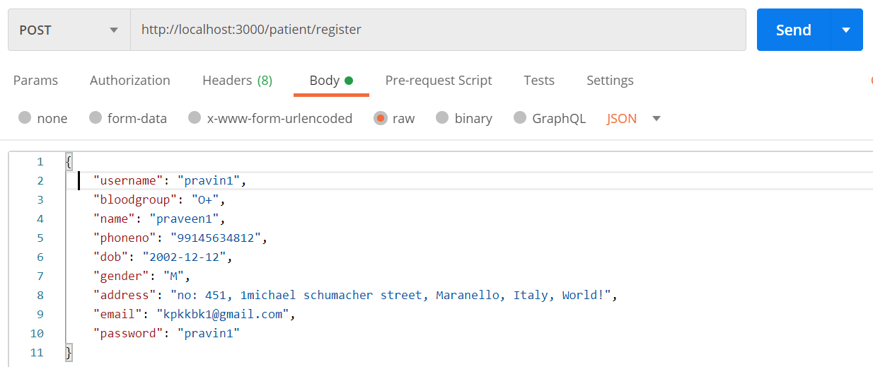

*Fig-9 Testing the patient models*

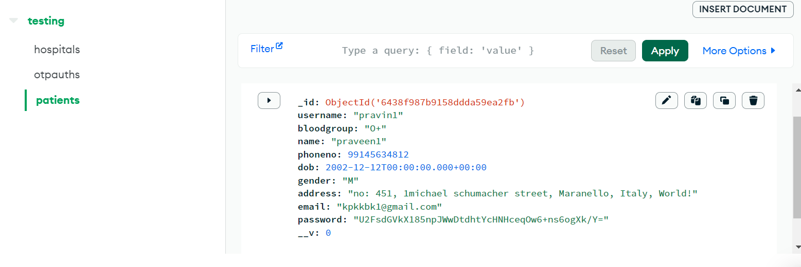

*Fig-10 Patient modules is stored in mongo DB*

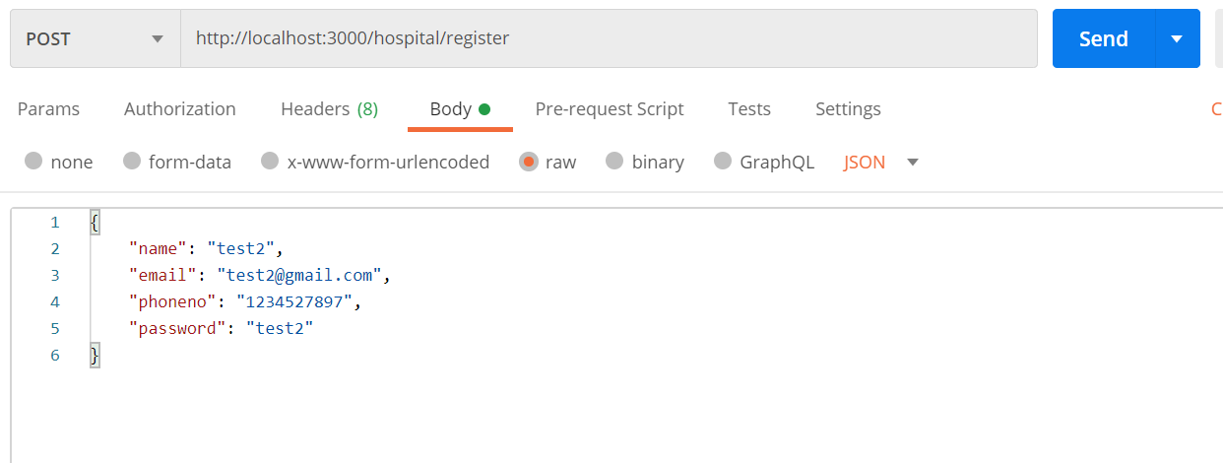

*Fig-11 Testing the hospital models*



*Fig-12 Hospital modules is stored in mongo DB*



*Fig-13 Testing the Password set by the user is encrypted*

**CHAPTER-7**

**RESULTS AND DISCUSSION**

A new system that manages your medical records. The technology that can provide your

doctor with all your medical history, enabling him to make more informed and precise

judgements. The centralized system would server patients of all ages and backgrounds

with the functionality like

• The ability for patients and hospitals to create accounts, log in, and access

medical records.

• The user has the option of resetting password.

• A search function that enables doctors to find patient’s medical records.

• Patient can upload medical record including reports and prescription in

pdf, jpeg and docx format.

• Patient portals is basically for patients to log into from their homes

to view, update and download their medical records or add new records.

• Hospital portals is basically for doctors to log into to view or add new

records of the patient who they are examining.

• For doctors to view the patients’ records, they need patients’ permission.

• The doctor can also add a new record for the patient he is consulting.

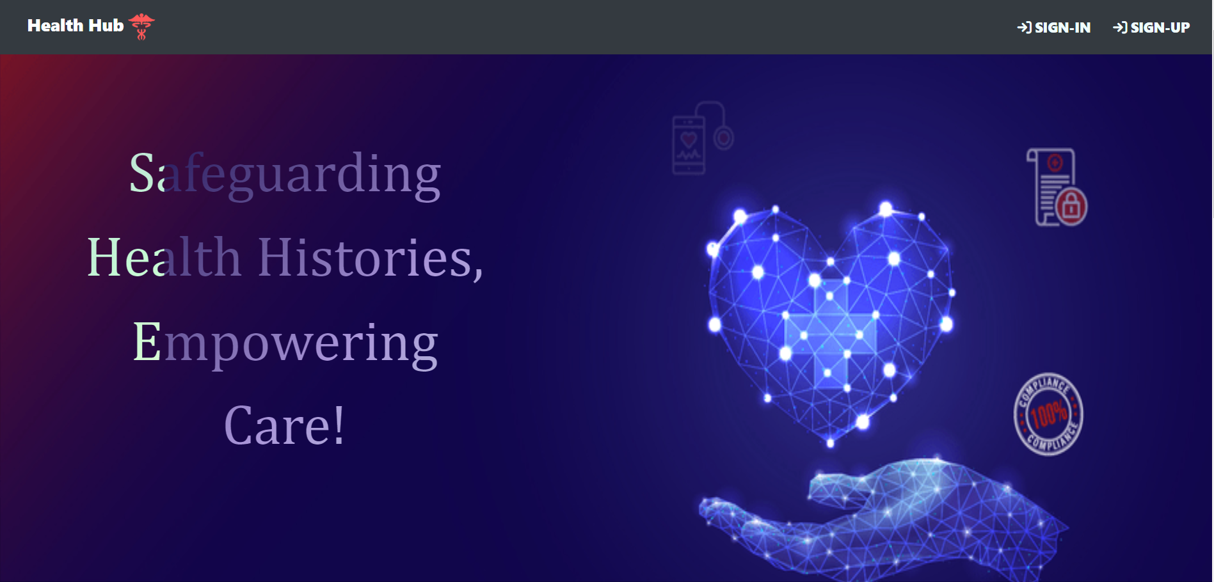

*Fig-14 Landing Page*

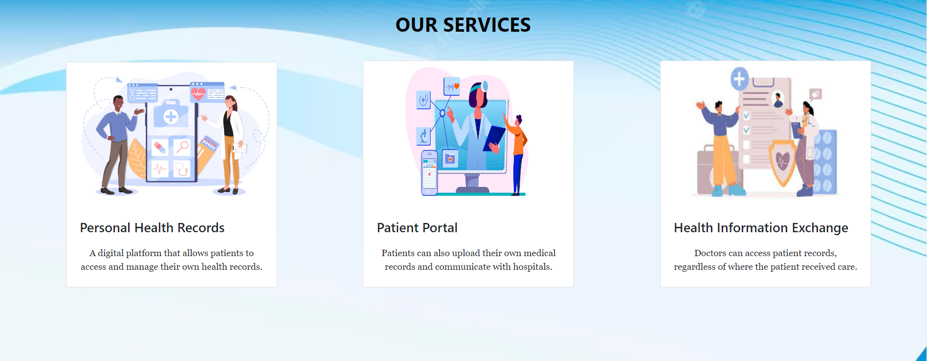

*Fig-15 Our Services*

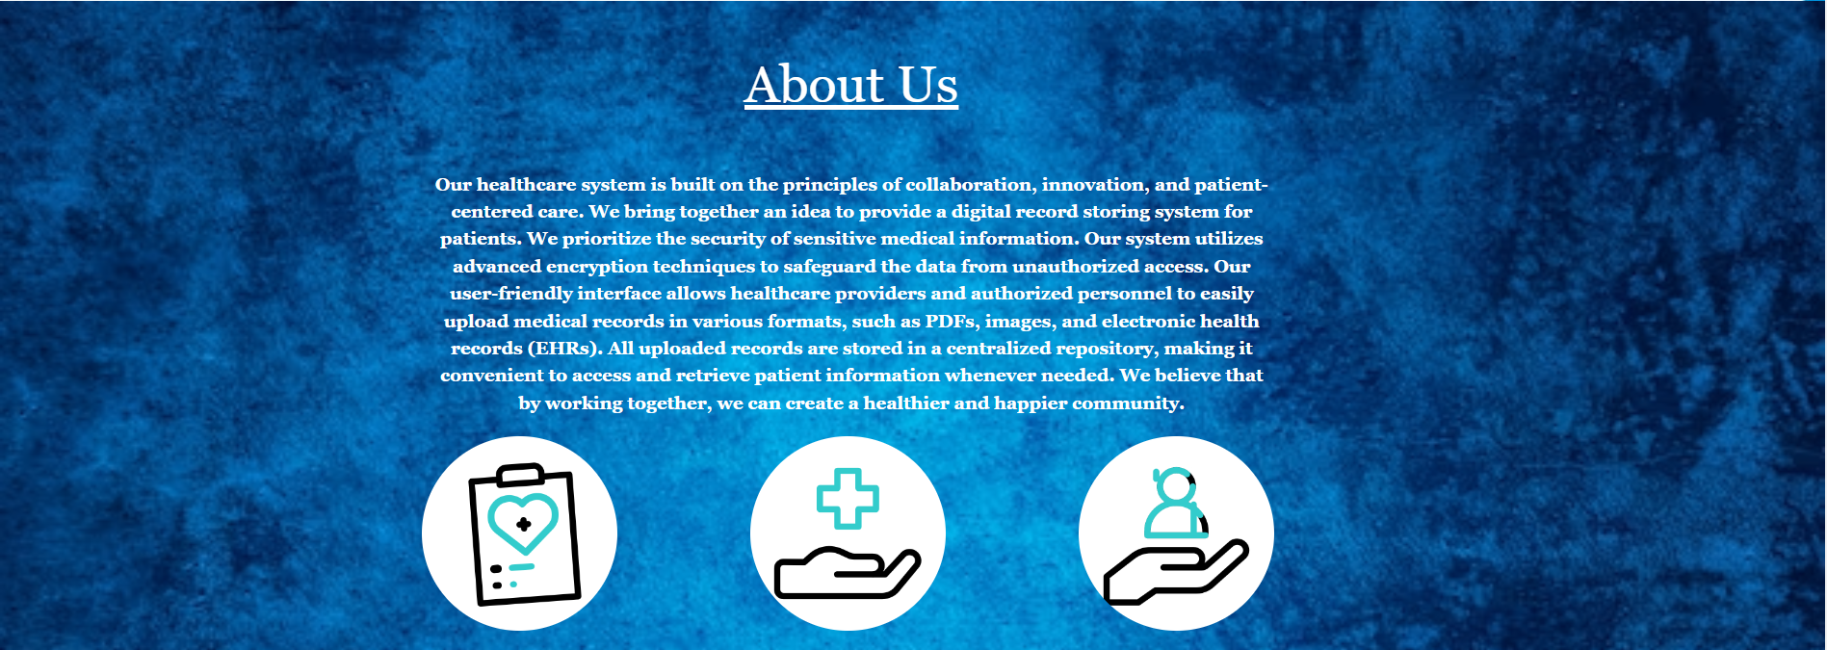

*Fig-16 About Us*



*Fig-17 Footer*

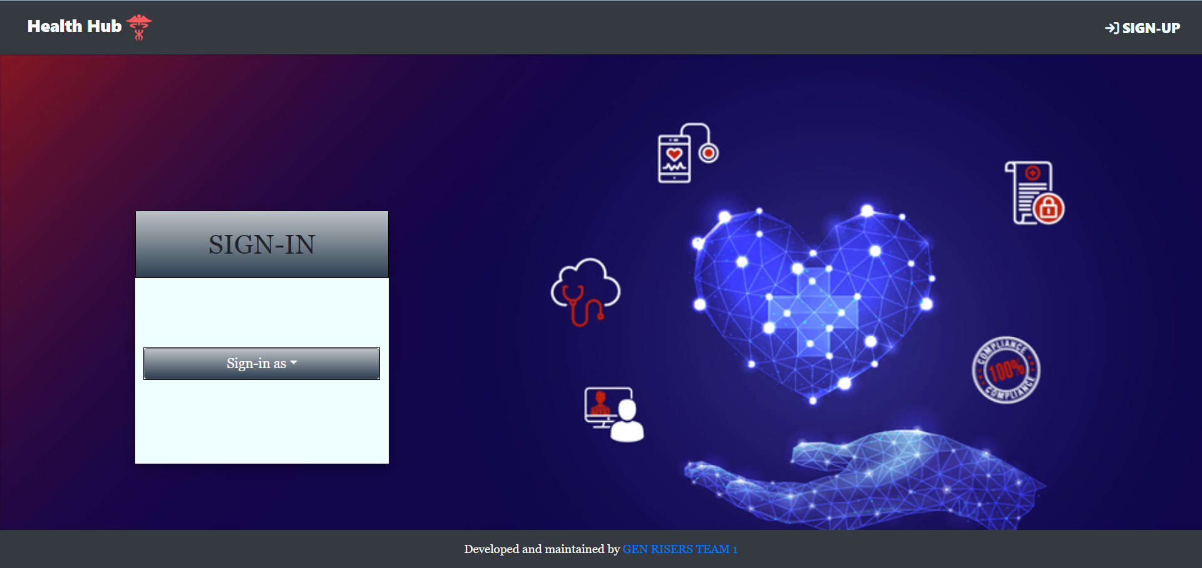

*Fig-18 Sign In*

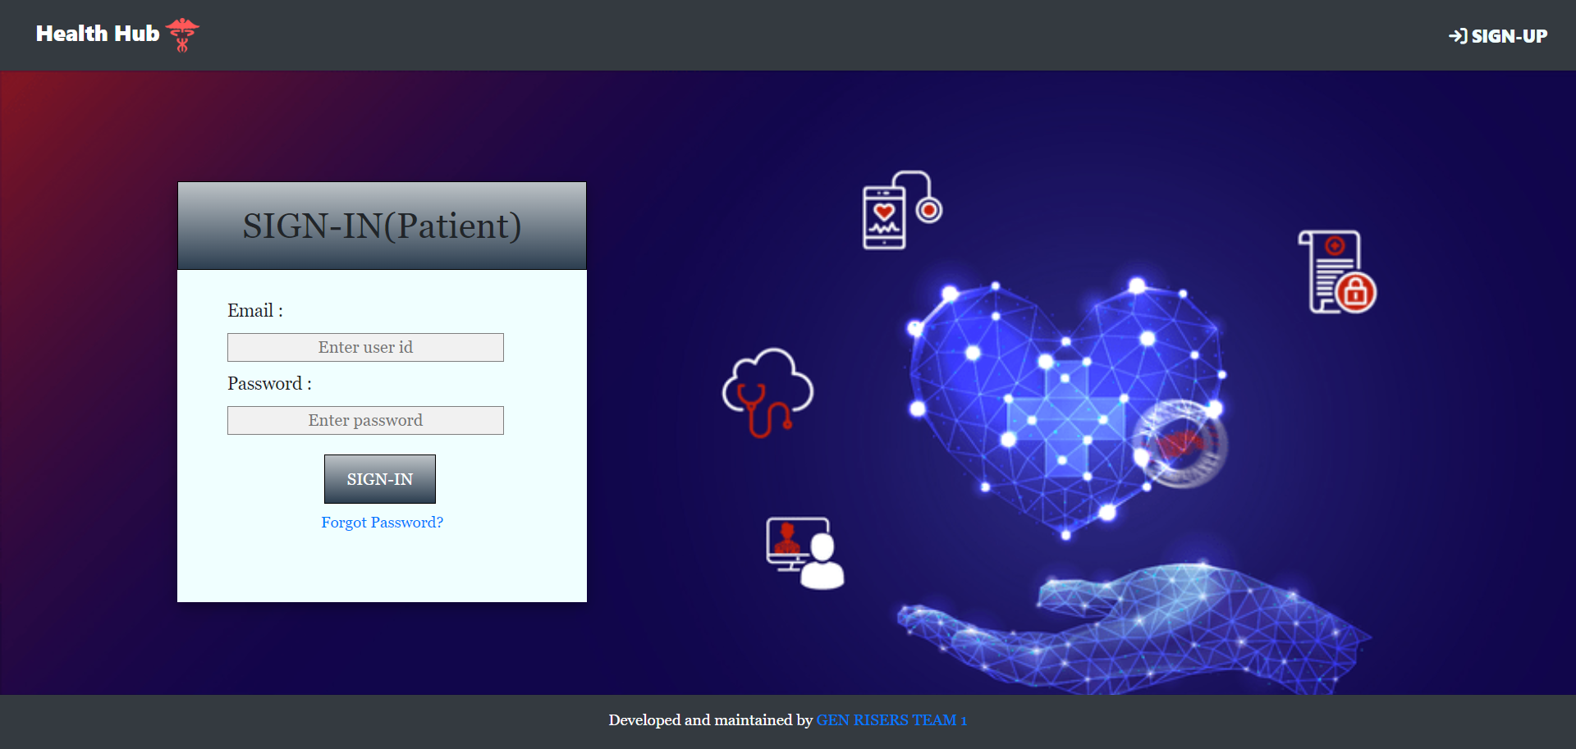

*Fig-19 Sign In(Patient)*

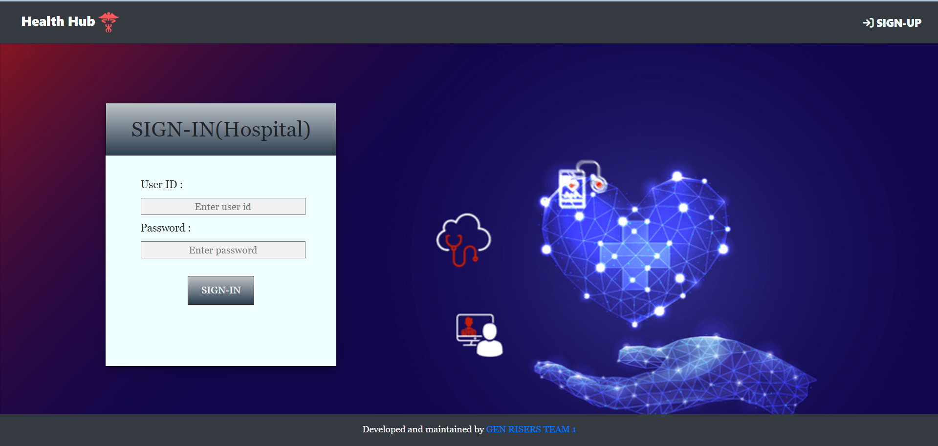

*Fig-20 Sign In(Hospital)*

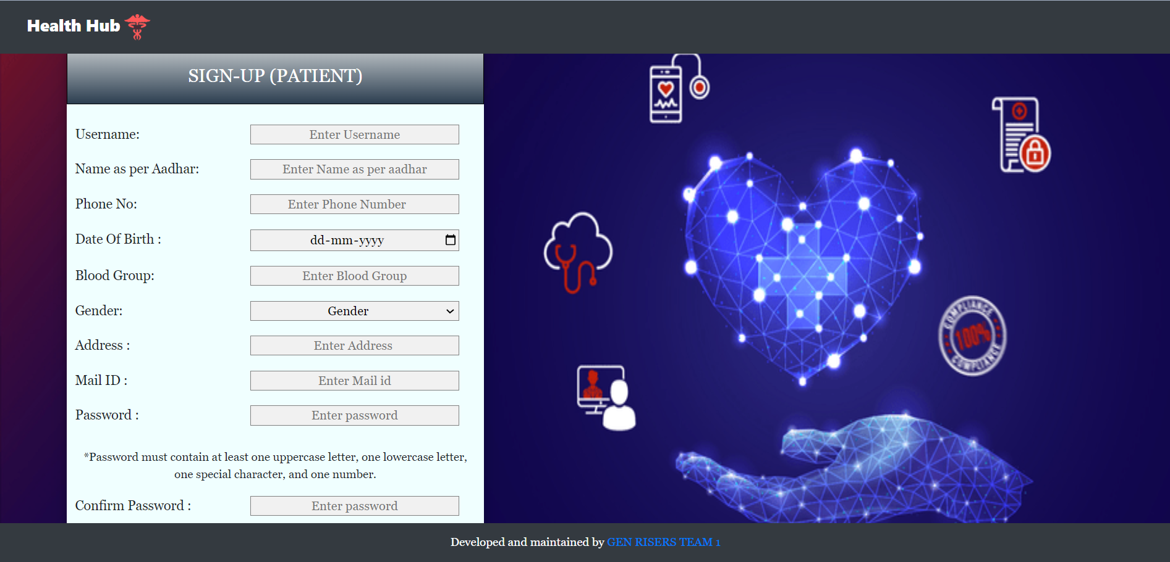

*Fig-21 Sign up (Patient)*

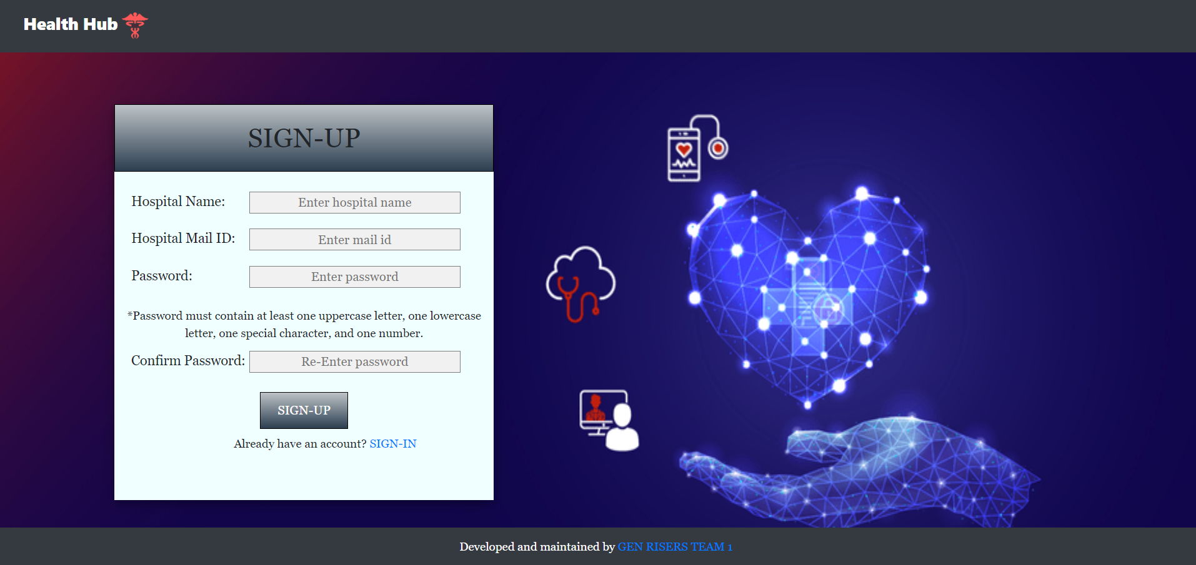

*Fig-22 Sign up (Hospital)*

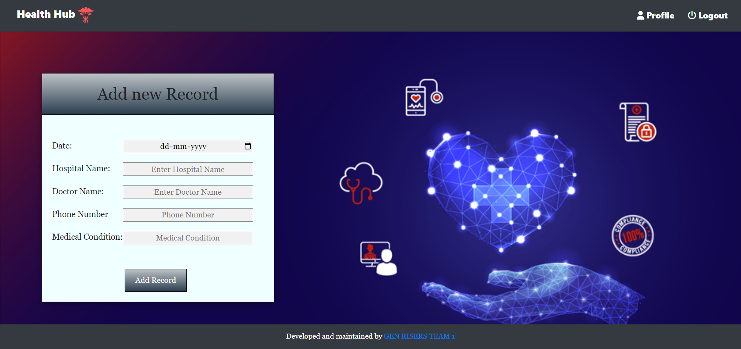

*Fig-23 Add New Record*

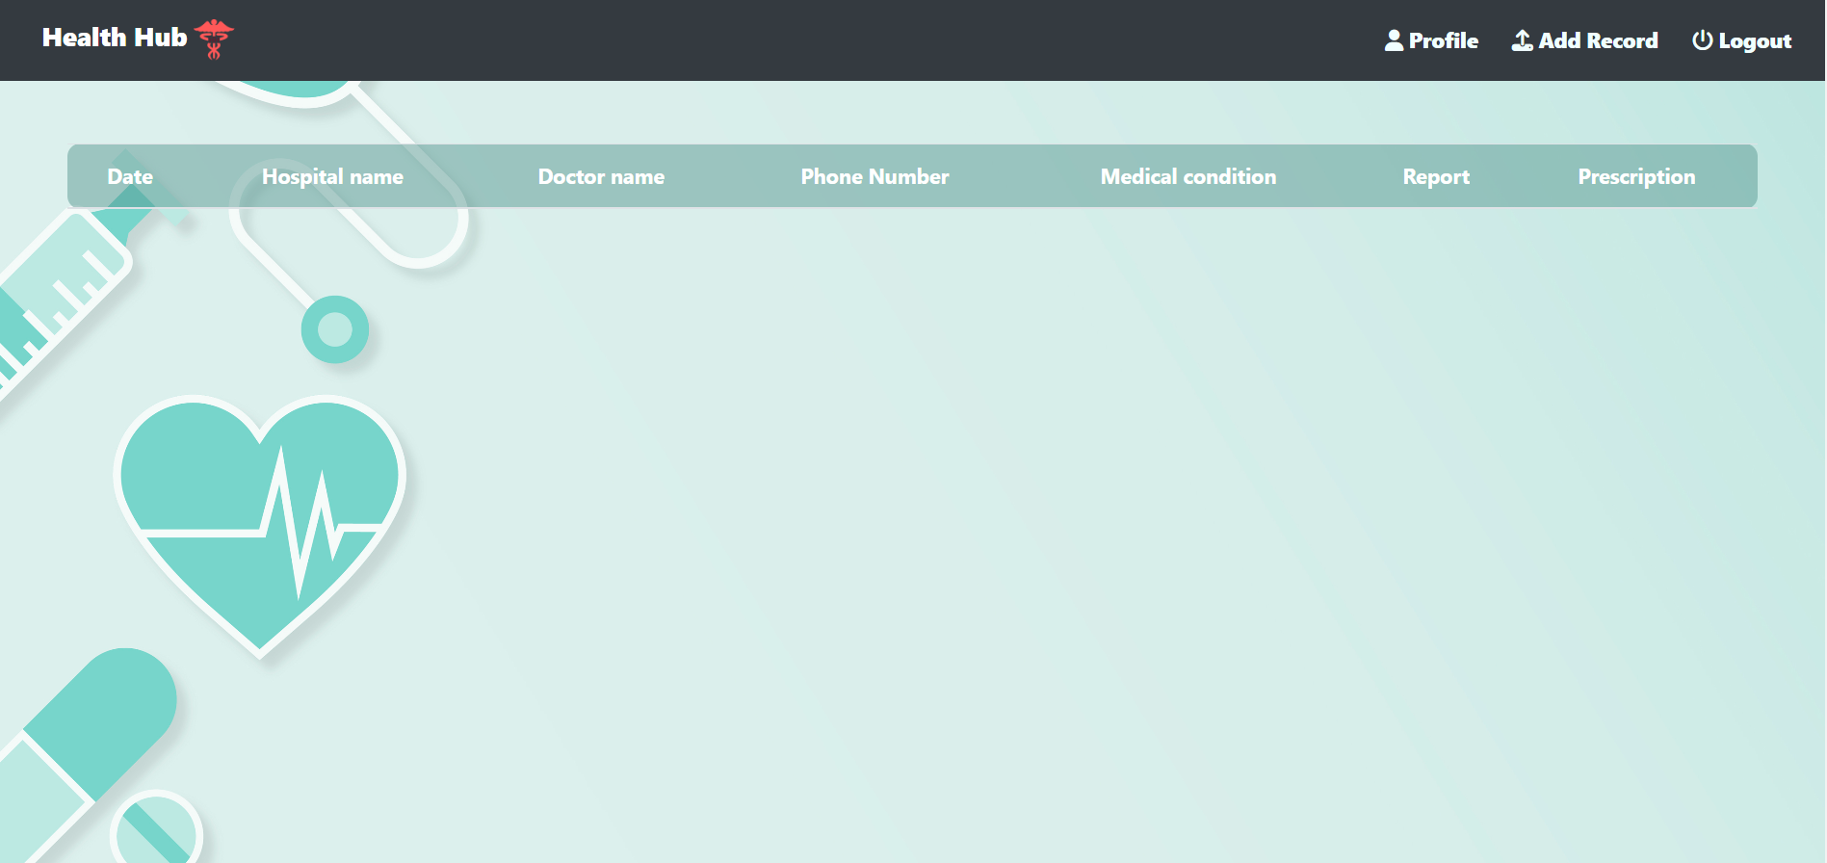

*Fig-24 Patients Home Page*

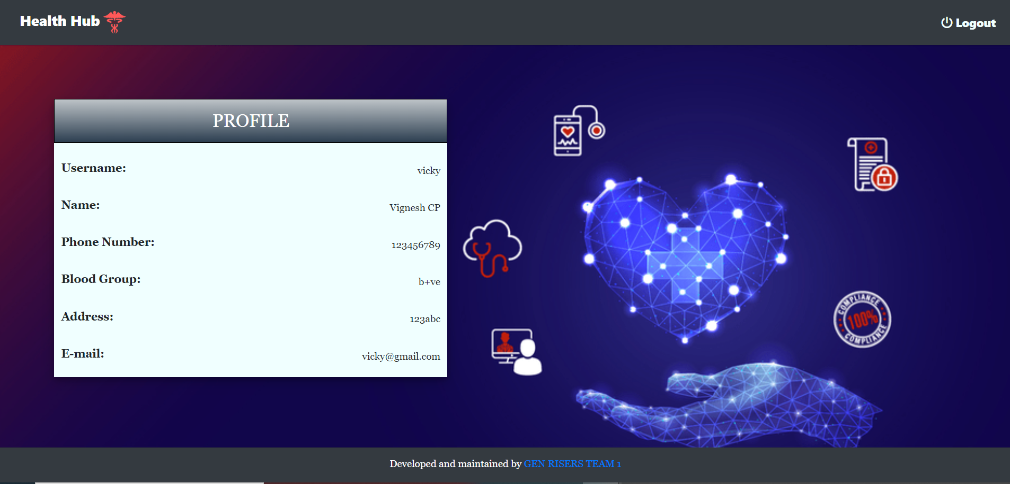

*Fig-25 Patients profile*

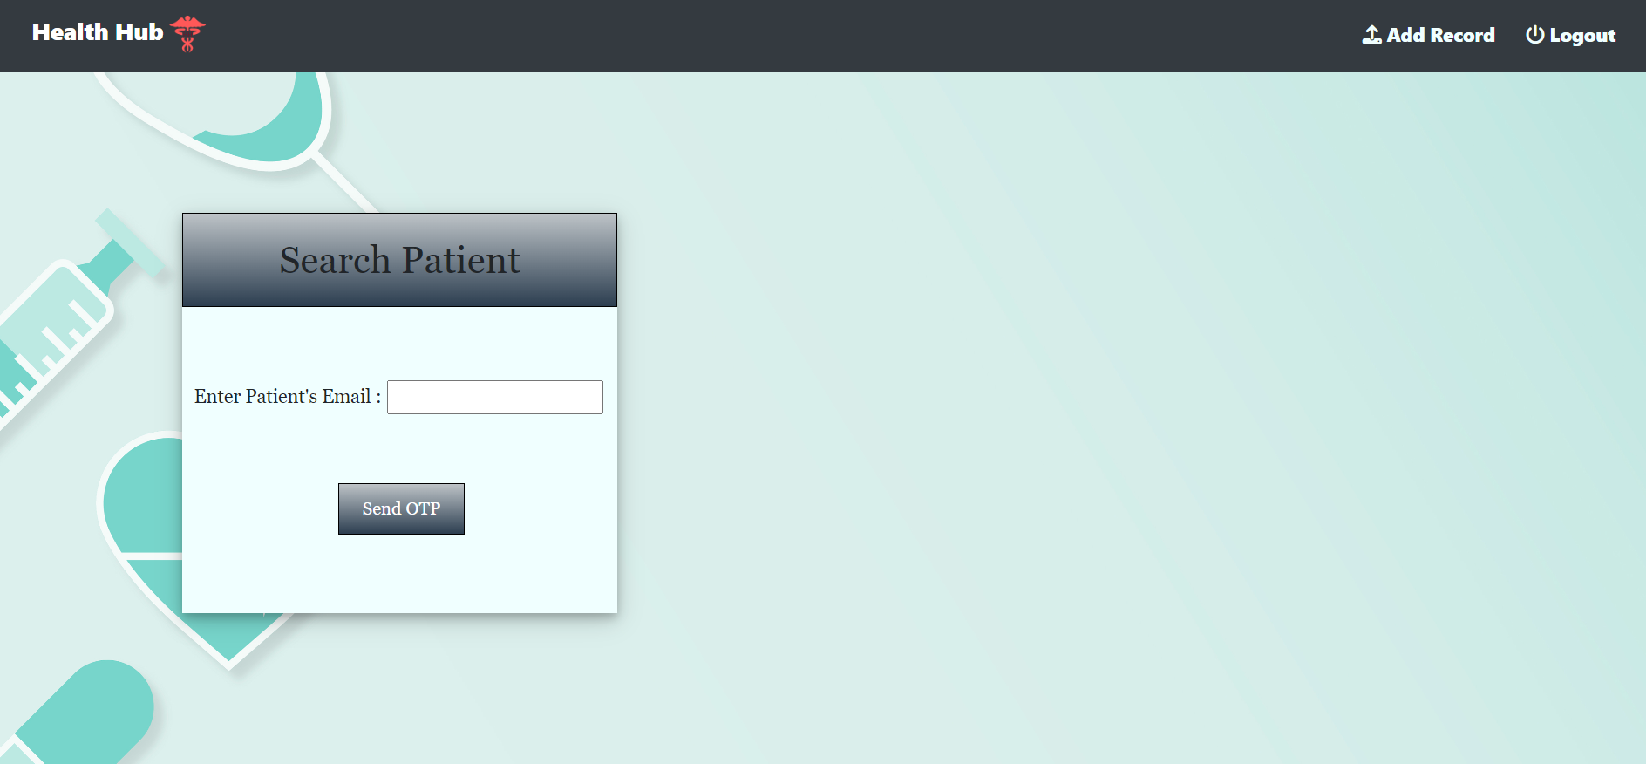

*Fig-26 Hospital Profile*

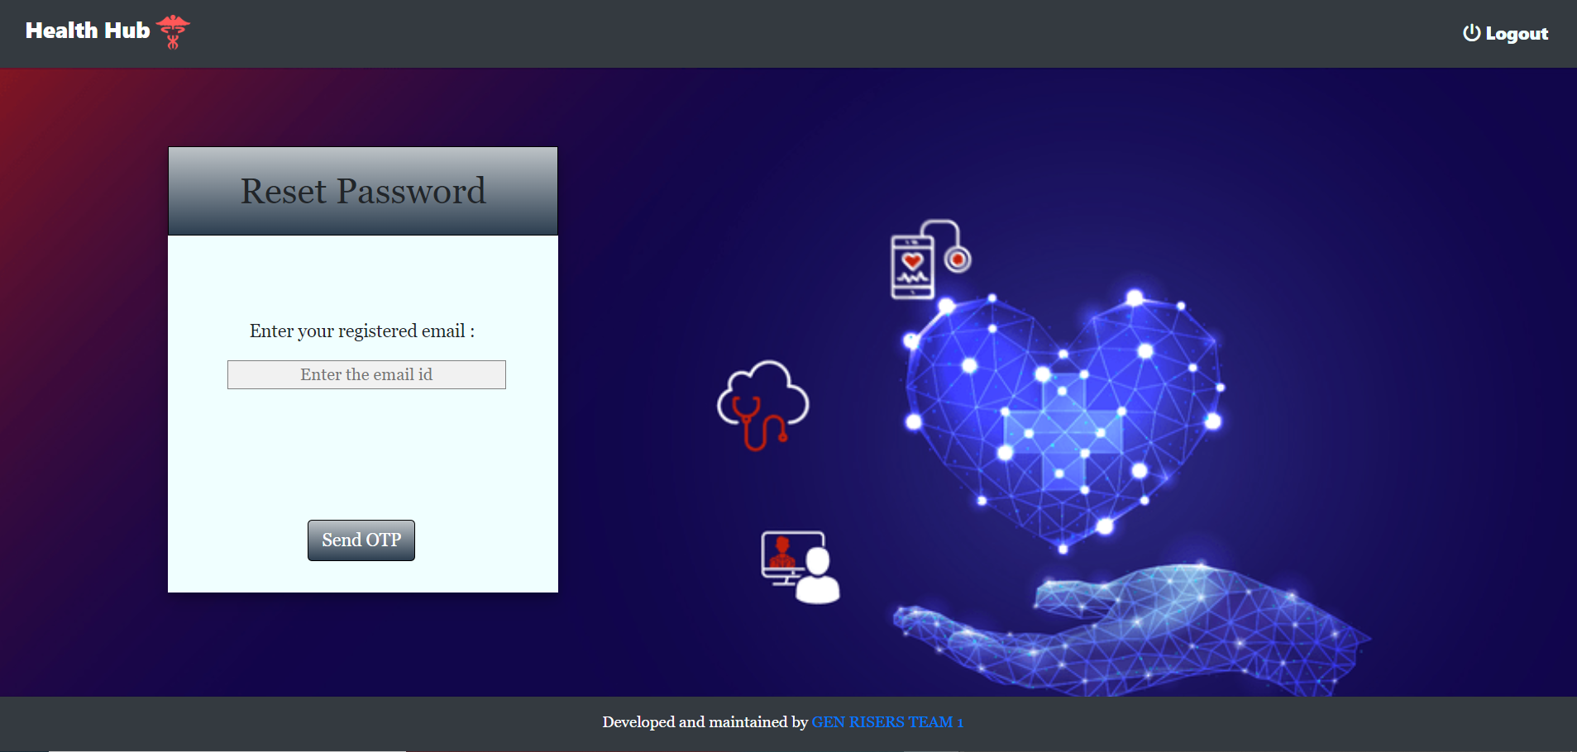

*Fig-27 Reset Password*

**CHAPTER-8**

**CONCLUSION**

In conclusion, the implementation of a centralized healthcare system has revolutionized the patient experience for individuals with chronic illnesses, addressing long-standing challenges and bringing about significant improvements in care delivery.

One of the most transformative aspects of this new system is the consolidation of medical records into a single, accessible platform. Gone are the days of patients having to repeat their medical history and undergo redundant tests or procedures due to fragmented information. With all their records in one place, doctors and specialists now have a comprehensive and up-to-date view of each patient's health journey. This holistic understanding enables healthcare providers to make more informed decisions, tailor treatment plans, and avoid unnecessary duplication of services, ultimately leading to better outcomes and reduced healthcare costs.

The centralized healthcare system also empowers patients with a renewed sense of control over their health. No longer burdened by the responsibility of managing and recalling intricate details of their medical history, individuals can place their trust in the system and focus on actively participating in their own care. The ease of access to complete medical records gives patients the confidence that their healthcare providers have all the necessary information at their fingertips, ensuring accurate diagnoses and appropriate treatment decisions.

Moreover, the personalized care plans offered by the centralized system further enhance the patient experience. Healthcare providers can now utilize comprehensive medical histories to design tailored treatment strategies that consider individual needs, preferences, and unique circumstances. This patient-centered approach fosters a stronger doctor-patient relationship, promoting collaboration and shared decision-making.

**CHAPTER-9**

**REFERENCES**

1. <https://www.himss.org/resources/benefits-centralized-electronic-health-record-system>
2. <https://www.sciencedirect.com/science/article/pii/S0167629611000868>
3. <https://www.sciencedirect.com/science/article/pii/S1386505610000811>
4. <https://www.jmir.org/2016/3/e87/>

<https://genpact.udemy.com/course/postman-crash-course-for-beginners-learn-rest-api-testing/learn/lecture/29620476?kw=API+testing&src=sac#overview>

1. <https://www.softwaretestinghelp.com/api-testing-tutorial/>
2. <https://webdesign.tutsplus.com/articles/a-beginners-guide-to-wireframing--webdesign-7399>
3. <https://developer.mozilla.org/en-US/docs/Learn/Getting_started_with_the_web/HTML_basics>

APPENDICES

import SignInPage from "./pages/SignInPage";

import SignUpPage from "./pages/SignUpPage";

import SignInForPatients from "./pages/SignInForPatients";

import SignInForHospital from "./pages/SignInForHospital";

import SignUpForHospital from "./pages/SignUpForHospital";

import SignUpForPatients from "./pages/SignUpForPatients";

import AddNewRecord from "./pages/AddNewRecords";

import PatientsHomePage from "./pages/PatientsHomePage";

import ResetPassword from "./pages/ResetPassword";

import Profile from "./pages/Profile";

import ReportUploadingPage from "./pages/ReportUploadingPage";

import RecordHospital from "./pages/RecordHospital"

import ReportHospital from "./pages/ReportHospital"

import PrescriptionHospital from "./pages/PrescriptionHospital"

import Details from "./pages/Details";

import Navbar from "./components/Navbar";

import AboutUs from "./pages/AboutUs";

import Enterotp from "./pages/Enterotp";

import HospitalHome from "./pages/HospitalHome";

import { BrowserRouter, Route, Routes } from "react-router-dom";

import PrescriptionPage from "./pages/PrescriptionPage";

import Verification from "./pages/Verification";

function Project() {

  return (

    <BrowserRouter>

      <Routes>

        <Route path="/SignInPage" element={<SignInPage></SignInPage>}></Route>

        <Route path="/SignUpPage" element={<SignUpPage></SignUpPage>}></Route>

        <Route

          path="/SignInForPatients"

          element={<SignInForPatients></SignInForPatients>}

        ></Route>

        <Route

          path="/SignInForHospital"

          element={<SignInForHospital></SignInForHospital>}

        ></Route>

        <Route

          path="/SignUpForHospital"

          element={<SignUpForHospital></SignUpForHospital>}

        ></Route>

        <Route

          path="/SignUpForPatients"

          element={<SignUpForPatients></SignUpForPatients>}

        ></Route>

        {/* <Route

          path="/AddNewRecord"

          element={<AddNewRecord></AddNewRecord>}

        ></Route> */}

        <Route

          path="/AddNewRecord"

          element={<AddNewRecord></AddNewRecord>}

        ></Route>

        <Route

          path="/AddNewRecord"

          element={<AddNewRecord></AddNewRecord>}

        ></Route>

        <Route

          path="/record-hospital"

          element={<RecordHospital></RecordHospital>}

        ></Route>

        <Route

          path="/report-hospital"

          element={<ReportHospital></ReportHospital>}

        ></Route>

        <Route

          path="/prescription-hospital"

          element={<PrescriptionHospital></PrescriptionHospital>}

        ></Route>

        <Route

          path="/PatientsHomePage"

          element={<PatientsHomePage></PatientsHomePage>}

        ></Route>

        <Route

          path="/ResetPassword"

          element={<ResetPassword></ResetPassword>}

        ></Route>

        <Route path="/Profile" element={<Profile></Profile>}></Route>

        <Route

          path="/HospitalHome"

          element={<HospitalHome></HospitalHome>}

        ></Route>

        <Route path="/Details" element={<Details></Details>}></Route>

        <Route path="/navbar" element={<Navbar></Navbar>}></Route>

        <Route path="/" element={<AboutUs></AboutUs>}></Route>

        <Route path="/enter-otp" element={<Enterotp></Enterotp>}></Route>

        <Route

          path="/upload-report"

          element={<ReportUploadingPage></ReportUploadingPage>}

        ></Route>

        <Route

          path="/upload-prescription"

          element={<PrescriptionPage></PrescriptionPage>}

        ></Route>

        <Route

          path="/reset-password"

          element={<Verification></Verification>}

        ></Route>

      </Routes>

    </BrowserRouter>

  );

}

export default Project;